A MAJOR PROJECT REPORT

ON

E-MARKETPLACE

SUBMITTED IN PARTIAL FULFILLMENT FOR AWARD OF DEGREE OF

BACHELOR OF TECHNOLOGY

IN

COMPUTER SCIENCE & ENGINEERING

BY

ABIJOT GUPTA (1701959)
ADITYA VIKRAM KATOCH(1701962)

UNDER THE GUIDANCE OF

DR. RC GANGWAR (PROFESSOR, CSE)



DEPARTMENT OF COMPUTER SCIENCE & ENGINEERING

BEANT COLLEGE OF ENGINEERING TECHNOLOGY, GURDASPUR

JAN-MAY, 2020
ABSTRACT
In recent times, it has become necessary for any business to have an online presence in order to remain relevant and competitive. As a result of this necessity many businesses, including small enterprises, now operate an e-commerce web store so as to increase sales and attract new customers. Also, business owners do not have to worry about finding a place to erect their stores and customers can have unhindered access to a wide range of products at any time and anywhere in the world.

The objective of this thesis project was to develop an e-commerce Java web application for a small retail store where the store owner sells his/her products online. The application allows the owner to manage products, customers, and orders. Also, with the application customers make orders and pay for the ordered products. The application uses Paytm Payment Checkout as its payment solution. In addition, the web store offers customers and visitors to the site an opportunity to subscribe to an email list in order to get news about new products and special offers. Lastly, the application sends an automatic email confirmation after completing an order or subscribing to an email list.

The development of this application was carried out on Eclipse IDE using the Java programming language. The database communication of the application was implemented by using JPA and JPQL, and MySQL database was used to store the application data. The application was structured according to the Model-View-Controller (MVC) pattern. The model, the view and the controller layers were implemented by using JavaBeans, JSPs, and Servlet API respectively. The payment transaction of the application was carried out on PayPal Sandbox (testing environment) with different NVP API operations.
ACKNOWLEDGEMENT
To complete a project the person associated with it must have dedication, patience, focus, and planning and skill ofcourse. With the absence of these attributes either the project never results desired outcome or not completed as expected. As all, I would like to thank all those who supported fully to make the desired project a running one. During the course many people supported as a motivator and as a mentor.
I would like to express my special gratitude and thanks to my project guide DR R.C. GANGWAR
whose constant guidance and for giving me such attention and time in the institute itself and for providing me different ideas which helps me in the project.

DR R.C. GANGWAR ABIJOT GUPTA
(Signature of Supervisor) (Signature of Supervisor)

TABLE OF CONTENTS

CHAPTER NO. | TITLE | PAGE NO.
1. | INTRODUCTION  - Introduction  - About Technology Used  - Features of Java  - About JDK  - MySQL | 1-13  1  2-3  4-9  9-10  11-13
2. | METHODLOGY  - Requirements  - Analysis  - Feasibility Study  - Design | 14-22  14  15-16  17-18  19-22
3. | MODULES  - Student Module  - Admin Module  - Screenshots | 23-39  23  23-24  25-39
4.  5. | CONCLUSION  FUTURE SCOPE  5.1 Future Scope of Application  - Software Scope | 40  41
 | REFERENCES | 42

CHAPTER 1

INTRODUCTION

E-Marketplace or Electronic Marketplace is a type of business model, or segment of a larger business model, that enables a firm or individual to conduct business over an electronic network, typically the internet. It operates in all four of the major market segments in India – business to business, business to consumer, consumer to consumer and consumer to business. Keeping a tab on the growing e-Commerce in India, Ministry of Consumer Affairs has released the draft guidelines on e-commerce for consumer protection. It will act as the guiding principles for e-commerce business for preventing fraud, unfair trade practices and protecting the legitimate rights and interests of consumers.
E-Marketplace is process of doing business through computer networks. The primary goal of an e-Marketplace site is to sell goods and services online. The sale and purchase transaction is completed electronically and interactively in real-time. User can login into e-marketplace website, once he logged in then automatically one shopping cart will be created, once user selects an item it will add to cart. In case user thinks the selected item is not useful for him, then he can delete that item form the cart.

1.1.1 Status of e-Commerce in India:
- India’s e-commerce sector has grown quickly despite an uncertain policy environment.
The e-commerce sector in India is estimated to reach USD 230 billion by 2028 (accounting for 10% of India’s retail).
- The e-commerce sector in India has been witnessing an explosive growth fuelled by the increase in the number of online users, growing penetration of smartphones and the rising popularity of social media platforms.
- The Indian e-commerce industry is expected to surpass the US to become the second largest e-commerce market in the world by 2034.
- Online shoppers in India are expected to reach 120 million in 2018 and eventually 220 million by 2025.
- Even in non-traditional items such as furniture and high-end fashion labels, growth has been phenomenal.
1.1.2 Current Policy Environment:
- It is still a work in progress when it comes to safeguarding customer interest.
- Consumers are still compelled to take wild chances in online transactions.
- There is little they can do if their calls go wrong, as returns and reimbursements are risky and cumbersome.
- There are no authentic ways to figure out if product reviews, ratings or even discounts are genuine.

1.2 DRAWBACKS OF EXISTING SYSTEM
The existing system of buying goods has several disadvantages. It requires lots of time to travel to the particular shop to buy the goods. It is having lots of manual work. Since everyone is leading busy life nowadays, time means a lot to everyone. Also there are expenses for travelling from house to shop. It is less user-friendly. In current system user must go to shop and order products. It is difficult to identify the required product. More over the shop from where we would like to buy something may not be open 24*7. Hence we have to adjust our time with the shopkeeper’s time or vendor’s time. In current e commerce system users have to go shop to view the description of the product. It is unable to generate different kinds of report.
E-Marketplace has made it easier for human to reduce physical work and to save time. E-Marketplace is fast gaining ground as an accepted and used business paradigm. Moreover there are various local Indian products which are far better than International brands which we are also promoting in this E-Marketplace.

1.2.1 E-Marketplace Disadvantages for Customers
- Privacy and security.
- Quality.
- Hidden costs.
- Delay in receiving goods.
- Need access to internet.
- Lack of personal interaction.

1.2.2 E-Marketplace Disadvantages for Businesses
- Security issues.
- Credit card issues
- Extra expense and expertise for e-commerce infrastructure.
- Needs for expanded reverse logistics.
- Sufficient internet service.
- Constant upkeep.

1.2.3 NON-TECHNICAL DISADVANTAGES
- The cost of creating / building E-Marketplace application in-house may be very high.
- There could be delay in launching the E-Marketplace application due to mistakes, lack of experience.
- User may not trust the site being unknown faceless seller. Such mistrust makes it difficult to make user switch from physical stores to online/virtual stores.
- Difficult to ensure security or privacy on online transactions .
- Lack of touch or feel of products during online shopping.
- E-Commerce applications are still evolving and changing rapidly.
- Internet access is still not cheaper and is inconvenient to use for many potential customers like one living in remote villages.

1.3 PROPOSED SYSTEM
The main advantage of e-commerce over traditional commerce is the user can browse online shops, compare prices and order merchandise sitting at home on their
Smartphones/PC. Secure registration and profile management facilities for customers. The basic concept of the application is to allow the customer to shop virtually using the Internet and allow customers to buy the items and articles of their desire from the store. Shopping Cart feature allows online shopping customers to “place” items in the cart. It decreases the cost of creating, processing, distributing, storing and retrieving paper-based information. This system expands the marketplace to national and international markets. Upon “checkout” the software calculates as total for the order including shipping and handling postage, packing and taxes, if applicable. It reduces the time between the outlay of capital and the receipt of products and services. Customers should be able to mail the Shop about the items they would like to see in the shop.
Purchasing of goods online, user can choose different products based on categories, online payments, delivery services. It provides consumers with more choices.
The proposed system helps in building a website to buy, sell products or goods online using internet connection. E-Marketplace websites provides consumers with less expensive products and services by allowing them to shop in many places and conduct quick comparisons.

1.3.1 Advantages to Customers
- 24x7 support. Customer can do transactions for the product or enquiry about any product/services provided by a company anytime, anywhere from any location. Here 24x7 refers to 24 hours of each seven days of a week.
- E-Marketplace application provides user more options and quicker delivery of products.
- E-Marketplace application provides user more options to compare and select the cheaper and better option. A customer can put review comments about a product and can see what others are buying or see the review comments of other customers before making a final buy.
- E-Marketplace provides option of virtual auctions.
- A customer can see the relevant detailed information within seconds rather than waiting for days or weeks.
- E-Marketplace increases competition among the organizations and as result organizations provides substantial discounts to customers.

1.3.2 Advantages to Society
- Customers need not to travel to shop a product thus less traffic on road and low air pollution.
- E-Marketplace helps reducing cost of products so less affluent people can also afford the products.
- E-Marketplace has enabled access to services and products to rural areas as well which are otherwise not available to them.
- E-Marketplace helps government to deliver public services like health care, education, social services at reduced cost and in improved way.

1.4 FEATURES
- Vocal for Local: In this E-Marketplace tribal can promote, market and sell tribal produce such as handicrafts, arts, paintings, minor forest products etc. online with provision of delivery and e-payment and promotional discounts.
Moreover, this marketplace also promotes our Indian best quality local products such as in my area Basmati Rice is very famous.
- Compulsory Return Policy: E-Marketplace accept returns in the event the products delivered are defective, wrong or spurious or if they do not have the characteristics or features advertised.
- Seller Details: E-Marketplace will also display details about the sellers on their website, especially the type of business furnished by the seller entity.
- Transparent Contract: This E-Marketplace increase transparency in contracts signed between e-commerce entities and the sellers, directing them to display terms of their contracts relating to aspects like return, refund, exchange, warranties and guarantees, delivery and shipment, mode of payments and redressing grievances.
- Grievance Redressal: This E-Marketplace has also sought transparency on the procedure followed to address complaints, directing e-commerce companies to publish contact details of their grievance officers on their websites and setting a one-month timeline for them to redress issues from the time the complaint is registered.
- Fair Pricing Policy: This E-Marketplace will not be directly or indirectly influence the price of the products and services they offer.
- Unfair Trade Practice: This E-Marketplace cannot adopt any trade practice for the purpose of promoting the sale, use or supply of any goods or services or use unfair and deceptive methods and practices that may influence the consumer’s transactional decisions.
- False Reviews: This E-Marketplace aim to restrict sellers from falsely representing themselves as consumers or posting reviews as well as misrepresenting and exaggerating the quality and features of products on their sites.
- Show Information: This E-Marketplace mention the 'expiry date' of goods offered for sale and the 'country of origin' of goods and services that are necessary for enabling the consumer to make an informed decision at the pre-purchase stage.
- Non-Cash Payment: E-Marketplace enables use of credit cards, debit cards, smart Cards, electronic fund transfer via bank's website and other modes of electronics payment.
- Advertising / Marketing: E-Marketplace increases the reach of advertising of products and services of businesses. It helps in better marketing management of products / services.
- Improved Sales: Using E-Marketplace, orders for the products can be generated anytime, anywhere without any human intervention. By this way, dependencies to buy a product reduce at large and sales increases.
- Communication improvement: E-Marketplace provides ways for faster, efficient, reliable communication with customers and partners.

2.4.1 FEASIBILITY STUDY:
Feasibility study is made to see if the project on completion will serve the purpose of the organization for the amount of work, effort and the time that spend on it. Feasibility study lets the developer foresee the future of the project and the usefulness. A feasibility study of a system proposal is according to its workability, which is the impact on the organization, ability to meet their user needs and effective use of resources. Thus when a new application is proposed it normally goes through a feasibility study before it is approved for development.

The document provide the feasibility of the project that is being designed and lists various areas that were considered very carefully during the feasibility study of this project such as Technical, Economic and Operational feasibilities. The following are its features:

2.4.2 TECHNICAL FEASIBILITY:
The system must be evaluated from the technical point of view first. The assessment of this feasibility must be based on an outline design of the system requirement in the terms of input, output, programs and procedures. Having identified an outline system, the investigation must go on to suggest the type of equipment, required method developing the system, of running the system once it has been designed.
Technical issues raised during the investigation are:
- Does the existing technology sufficient for the suggested one?
- Can the system expand if developed?
The project should be developed such that the necessary functions and performance are achieved within the constraints. The project is developed within latest technology. Through the technology may become obsolete after some period of time, due to the fact that never version of same software supports older versions, the system may still be used. So there are minimal constraints involved with this project. The system has been developed using Java the project is technically feasible for development.
2.4.3 ECONOMIC FEASIBILITY
The developing system must be justified by cost and benefit. Criteria to ensure that effort is concentrated on project, which will give best, return at the earliest. One of the factors, which affect the development of a new system, is the cost it would require.
The following are some of the important financial questions asked during preliminary investigation:
- The costs conduct a full system investigation.
- The cost of the hardware and software.
- The benefits in the form of reduced costs or fewer costly errors.
Since the system is developed as part of project work, there is no manual cost to spend for the proposed system. Also all the resources are already available, it give an indication of the system is economically possible for development.

2.4.4 BEHAVIORAL FEASIBILITY
This includes the following questions:
- Is there sufficient support for the users?
- Will the proposed system cause harm?
The project would be beneficial because it satisfies the objectives when developed and installed. All behavioural aspects are considered carefully and conclude that the project is behaviourally feasible.

1.2.1 INTRODUCTION TO JAVA
Java is general purpose and most popular object-oriented language. Due to its simplicity and easy to learn feature, it is first choice of programmer today. The java programming language is related to C and C++ but rather differently, with many sources of bug and complex feature of C and C++ omitted and a few ideas from other language is included. In addition to object oriented feature it provides such platform independence, security, multithreading, portability etc. Which makes it well suited for the web and networked services, application, platform independent desktop, robotics and any other embedded devices. Java was developed by James Gosling in January 1991. The idea was conceived by J.G, Mike Sheridan and Patrick Naughton. Java is used in all kind of applications like Mobile Applications (Android is Java based), desktop applications, web applications, client server applications, enterprise applications and many more.

1.2.2 HISTORY OF JAVA

The idea of java was conceived in January 1991 by James Gosling, Mike Sheridan, Patrick Naughton and several other individuals who met in Aspen, Colorado to discuss the stealth project. The language initially called oak after an oak tree that stood outside gosling’s office .later the project went by the name green and was and finally rename java from java coffee .This project was started due to the profound impact of microprocessor in intelligent consumer-electronic device such as PDAs, television set up boxes, VCRs etc. The goal of this project was to control microprocessor embedded in consumer-electronics devices. To serve these goals a platform independent, reliable and compact language was need James Gosling, who was given the task to identify the proper programming language for project, initially began with C++, the language that most programmers were parsing because of its object-oriented nature. Because of the complex feature of C++ such as memory leaks, multiple inheritance etc. Sun Microsystems released the first public implementation as Java 1.0 in 1996. It promised "Write Once, Run Anywhere" (WORA), providing no-cost run-times on popular platforms.

1.3 Versions
List of java version so far come
- JDK 1.0 (January 23, 1996)
- JDK 1.1 (February 19, 1997)
- J2SE 1.2 (December 8, 1998)
- J2SE 1.3 (May 8, 2000)
- J2SE 1.4 (February 6, 2002)
- J2SE 5.0 (September 30, 2004)
- Java SE 6 (December 11, 2006)
- Java SE 7 (July 28, 2011)
- Java SE 8 (March 18, 2014)
- Java SE 9 (September 21, 2017)
- Java SE 10 (March 20, 2018)
- Java SE 11 (September 25, 2018)
- Java SE 12 (March 19, 2019.)
- Java SE 13 (September 25, 2018)
- Java SE 14 (March 17, 2020.

1.4 FEATURES OF JAVA
Platform Independent:
The concept of Write-once-run-anywhere (known as the Platform independent) is one of the important key feature of java language that makes java as the most powerful language. Not even a single language is idle to this feature but java is closer to this feature. The programs written on one platform can run on any platform provided the platform must have the JVM.
Simple:
There are various features that make the java as a simple language. Programs are easy to write and debug because java does not use the pointers explicitly. It is much harder to write the java programs that can crash the system but we cannot say about the other programming languages. Java provides the bug free system due to the strong memory management. It also has the automatic memory allocation and de-allocation system.
Robust:
Java has the strong memory allocation and automatic garbage collection mechanism. It provides the powerful exception handling and type checking mechanism as compare to other programming languages. Compiler checks the program whether there any error and interpreter checks any run time error and makes the system secure from crash. All of the above features makes the java language robust.
Portable:
The feature Write-once-run-anywhere makes the java language portable provided that the system must have interpreter for the JVM. Java also have the standard data size irrespective of operating system or the processor. These features make the java as a portable language

PORTABLE
OBJECT ORIENTED

MULTI -THREADED
DISTRIBUTED
JAVA
FEATURES

SECURE
ROBUST

DYANAMIC
SIMPLE
INTERPRETED

Object Oriented:
To be an Object Oriented language, any language must follow at least the four characteristics.
- Inheritance: It is the process of creating the new classes and using the behavior of the existing classes by extending them just to reuse the existing code and adding the additional features as needed.
- Encapsulation: It is the mechanism of combining the information and providing the abstraction.
- Polymorphism: As the name suggest one name multiple form, Polymorphism is the way of providing the different functionality by the functions having the same name based on the signatures of the methods.
- Dynamic binding: Sometimes we don't have the knowledge of objects about their specific types while writing our code. It is the way of providing the maximum functionality to a program about the specific type at runtime.
As the languages like Objective C, C++ fulfils the above four characteristics yet they are not fully object oriented languages because they are structured as well as object oriented languages. But in case of java, it is a fully Object Oriented language because object is at the outer most level of data structure in java. No standalone methods, constants, and variables are there in java. Everything in java is object even the primitive data types can also be converted into object by using the wrapper class.
Distributed:
The widely used protocols like HTTP and FTP are developed in java. Internet programmers can call functions on these protocols and can get access the files from any remote machine on the internet rather than writing codes on their local system.
Dynamic:
While executing the java program the user can get the required files dynamically from a local drive or from a computer thousands of miles away from the user just by connecting with the Internet.
Secure:
Java does not use memory pointers explicitly. All the programs in java are run under an area known as the sand box. Security manager determines the accessibility options of a class like reading and writing a file to the local disk. Java uses the public key encryption system to allow the java applications to transmit over the internet in the secure encrypted form. The byte code Verifier checks the classes after loading.
Performance:
Java uses native code usage, and lightweight process called threads. In the beginning interpretation of byte code resulted the performance slow but the advance version of JVM uses the adaptive and just in time compilation technique that improves the performance.
Multithreaded:
Java is also a multithreaded programming language. Multithreading means a single program having different threads executing independently at the same time. Multiple threads execute instructions according to the program code in a process or a program. Multithreading works the similar way as multiple processes run on one computer.
Multithreading programming is a very interesting concept in Java. In multithreaded programs not even a single thread disturbs the execution of other thread. Threads are obtained from the pool of available ready to run threads and they run on the system CPUs. This is how Multithreading works in Java which you will soon come to know in details in later chapters.
Interpreted:
We all know that Java is an interpreted language as well. With an interpreted language such as Java, programs run directly from the source code. The interpreter program reads the source code and translates it on the fly into computations. Thus, Java as an interpreted language depends on an interpreter program. The versatility of being platform independent makes Java to outshine from other languages. The source code to be written and distributed is platform independent. Another advantage of Java as an interpreted language is its error debugging quality. Due to this any error occurring in the program gets traced. This is how it is different to work with Java.
Architecture Neutral:
The term architectural neutral seems to be weird, but yes Java is an architectural neutral language as well. The growing popularity of networks makes developers think distributed. In the world of network it is essential that the applications must be able to migrate easily to different computer systems. Not only to computer systems but to a wide variety of hardware architecture and operating system architectures as well. The Java compiler does this by generating byte code instructions, to be easily interpreted on any machine and to be easily translated into native machine code on the fly. The compiler generates an architecture-neutral object file format to enable a Java application to execute anywhere on the network and then the compiled code is executed on many processors, given the presence of the Java runtime system. Hence Java was designed to support applications on network. This feature of Java has thrived the programming language.
ABOUT : JDK:
The Java Development Kit (JDK) is a Sun Microsystems product aimed at Java developers. Since the introduction of Java, it has been by far the most widely used Java SDK. On 17 November 2006, Sun announced that it would be released under the GNU General Public License (GPL), thus making it free software. This happened in large part on 8 May 2007^{[1]} and the source code was contributed to the OpenJDK.
The primary components of the JDK are a selection of programming tools, including:
- java – The loader for Java applications. This tool is an interpreter and can interpret the class files generated by the javac compiler. Now a single launcher is used for both development and deployment. The old deployment launcher, jre, is no longer provided with Sun JDK.
- javac – The compiler, which converts source code into Java bytecode
- jar – The archiver, which packages related class libraries into a single JAR file. This tool also helps manage JAR files.
- javadoc – The documentation generator, which automatically generates documentation from source code comments
- jdb – The debugger
- javap – The class file disassembler
- appletviewer – This tool can be used to run and debug Java applets without a web browser.
- javah – The C header and stub generator, used to write native methods
- extcheck – This utility can detect JAR-file conflicts.
- apt – The annotation processing tool
- jhat – (Experimental) Java heap analysis tool
- jstack – (Experimental) This utility prints Java stack traces of Java threads.
- jstat – (Experimental) Java Virtual Machine statistics monitoring tool
- jstatd – (Experimental) jstat daemon
- jinfo – (Experimental) This utility gets configuration information from a running Java process or crash dump.
- jmap – (Experimental) This utility outputs the memory map for Java and can print shared object memory maps or heap memory details of a given process or core dump.
- idlj – The IDL-to-Java compiler. This utility generates Java bindings from a given IDL file.
- policy tool – The policy creation and management tool, which can determine policy for a Java runtime, specifying which permissions are available for code from various sources
- VisualVM – visual tool integrating several command line JDK tools and lightweight performance and memory profiling capabilities
The JDK also comes with a complete Java Runtime Environment, usually called a private runtime. It consists of a Java Virtual Machine and all of the class libraries that will be present in the production environment, as well as additional libraries only useful to developers, such as the internationalization libraries and the IDL libraries.
Also included are wide selections of example programs demonstrating the use of almost all portions of the Java API.

Java 2 Enterprise Edition(J2EE):
The J2EE platform uses a multitier distributed application model. Application logic is divided into components according to function, and the various application components that make up a J2EE application are installed on different machines depending on the tier in the multitier J2EE environment to which the application component belongs. Figure 1-1 shows two multitier J2EE applications divided into the tiers described in the following list. The J2EE application parts shown in Figure 1-1 are presented in J2EE Components.
- Client-tier components run on the client machine.
- Web-tier components run on the J2EE server.
- Business-tier components run on the J2EE server.
- Enterprise information system (EIS)-tier software runs on the EIS server.
Although a J2EE application can consist of the three or four tiers shown in Figure 1-1, J2EE multitier applications are generally considered to be three-tiered applications because they are distributed over three different locations: client machines, the J2EE server machine, and the database or legacy machines at the back end. Three-tiered applications that run in this way extend the standard two-tiered client and server model by placing a multithreaded application server between the client application and back-end storage.
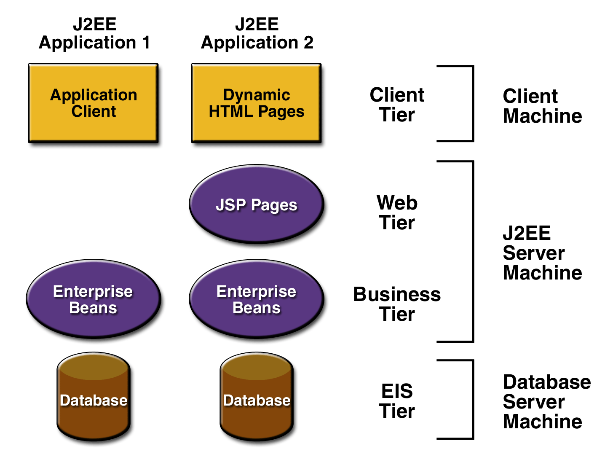
Figure 1-1 Multitiered Applications

J2EE COMPONENTS
J2EE applications are made up of components. A J2EE component is a self-contained functional software unit that is assembled into a J2EE application with its related classes and files and that communicates with other components. The J2EE specification defines the following J2EE components:
- Application clients and applets are components that run on the client.
- Java Server and Java Server Pages (JSP) technology components are Web components that run on the server.
- Enterprise JavaBeans (EJB) components (enterprise beans) are business components that run on the server.
J2EE components are written in the Java programming language and are compiled in the same way as any program in the language. The difference between J2EE components and "standard" Java classes is that J2EE components are assembled into a J2EE application, verified to be well formed and in compliance with the J2EE specification, and deployed to production, where they are run and managed by the J2EE server.

J2EE Clients
A J2EE client can be a Web client or an application client.

Web Clients
A Web client consists of two parts: dynamic Web pages containing various types of markup language (HTML, XML, and so on), which are generated by Web components running in the Web tier, and a Web browser, which renders the pages received from the server.
A Web client is sometimes called a thin client. Thin clients usually do not do things like query databases, execute complex business rules, or connect to legacy applications. When you use a thin client, heavyweight operations like these are off-loaded to enterprise beans executing on the J2EE server where they can leverage the security, speed, services, and reliability of J2EE server-side technologies.

Application Clients:
A J2EE application client runs on a client machine and provides a way for users to handle tasks that require a richer user interface than can be provided by a markup language. It typically has a graphical user interface (GUI) created from Swing or Abstract Window Toolkit (AWT) APIs, but a command-line interface is certainly possible.
Application clients directly access enterprise beans running in the business tier. However, if application requirements warrant it, a J2EE application client can open an HTTP connection to establish communication with a servlet running in the Web tier.

JavaBeans Component Architecture:
The server and client tiers might also include components based on the JavaBeans component architecture (JavaBeans component) to manage the data flow between an application client or applet and components running on the J2EE server or between server components and a database. JavaBeans components are not considered J2EE components by the J2EE specification.
JavaBeans components have instance variables and get and set methods for accessing the data in the instance variables. JavaBeans components used in this way are typically simple in design and implementation, but should conform to the naming and design conventions outlined in the JavaBeans component architecture.

J2EE Server Communications:
The client communicates with the business tier running on the J2EE server either directly or, as in the case of a client running in a browser, by going through JSP pages or servlets running in the Web tier.J2EE application uses a thin browser-based client or thick application client. In deciding which one to use, you should be aware of the trade-offs between keeping functionality on the client and close to the user (thick client) and off-loading as much functionality as possible to the server (thin client). The more functionality you off-load to the server, the easier it is to distribute, deploy, and manage the application; however, keeping more functionality on the client can make for a better perceived user experience.
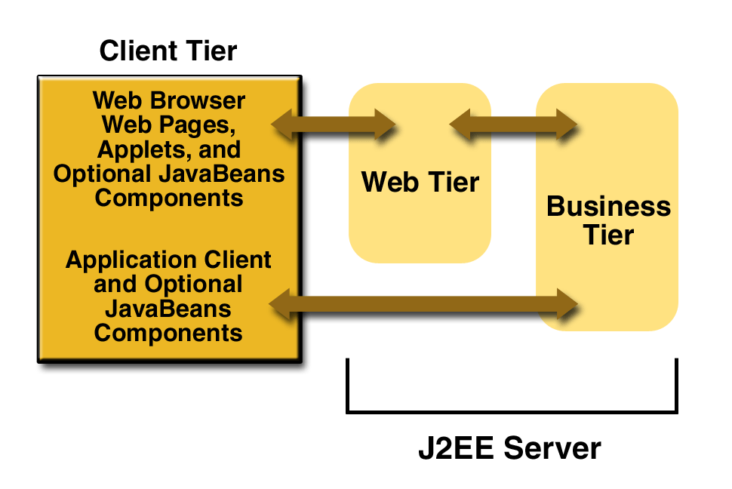

Figure 1-2 Server Communications :
Web Components
J2EE Web components can be either servlets or JSP pages. Servlets are Java programming language classes that dynamically process requests and construct responses. JSP pages are text-based documents that execute as servlets but allow a more natural approach to creating static content. Static HTML pages and applets are bundled with Web components during application assembly, but are not considered Web components by the J2EE specification. Server-side utility classes can also be bundled with Web components and, like HTML pages, are not considered Web components. Like the client tier and as shown in Figure 1-3, the Web tier might include a JavaBeans component to manage the user input and send that input to enterprise beans running in the business tier for processing.
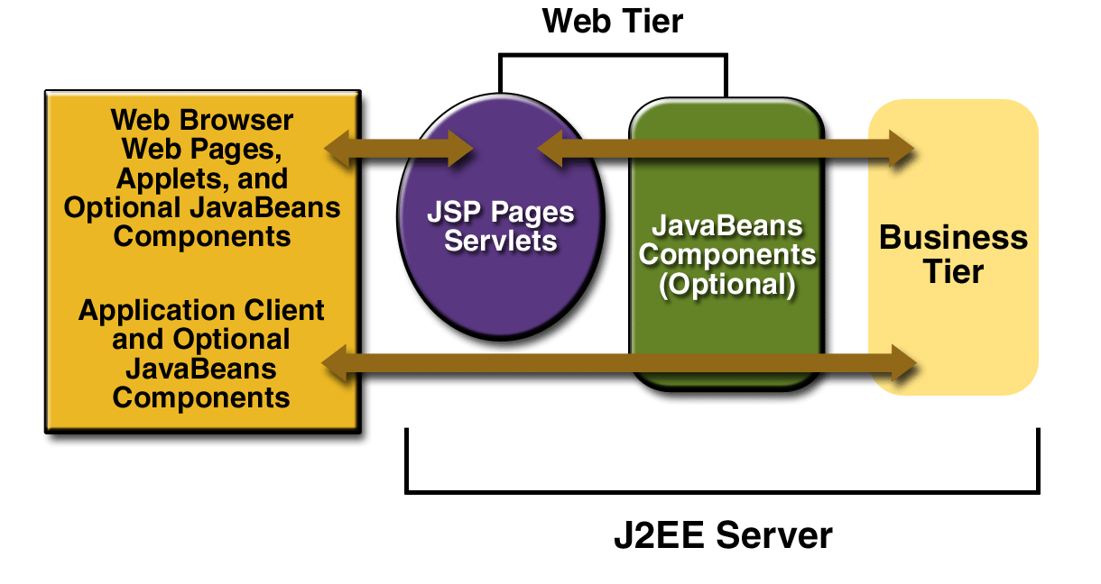
Figure 1-3 Web Tier and J2EE Application

Business Components
Business code, which is logic that solves or meets the needs of a particular business domain such as banking, retail, or finance, is handled by enterprise beans running in the business tier. An enterprise bean also retrieves data from storage, processes it (if necessary), and sends it back to the client program.
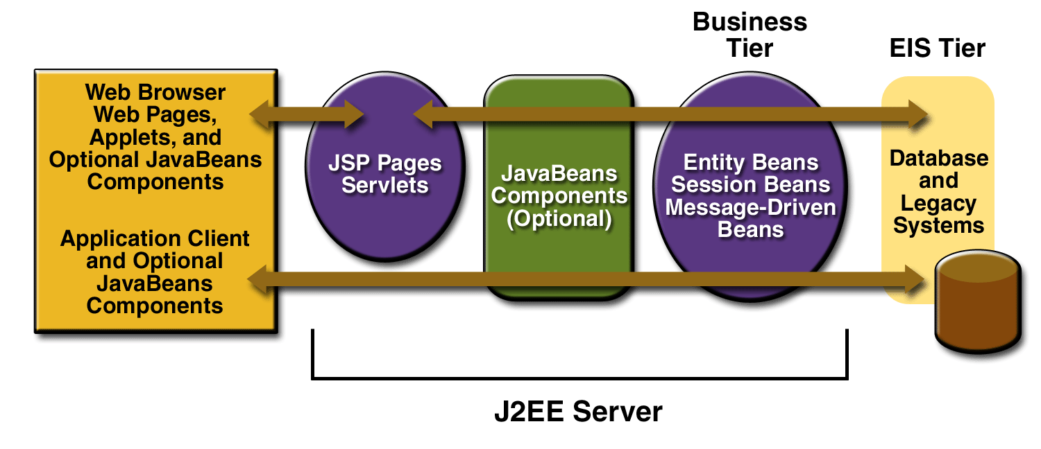
Figure 1-4 Business and EIS Tiers

There are three kinds of enterprise beans: session beans, entity beans, and message-driven beans. A session bean represents a transient conversation with a client. When the client finishes executing, the session bean and its data are gone. In contrast, an entity bean represents persistent data stored in one row of a database table. If the client terminates or if the server shuts down, the underlying services ensure that the entity bean data is saved.
A message-driven bean combines features of a session bean and a Java Message Service (JMS) message listener, allowing a business component to receive JMS messages asynchronously.

Enterprise Information System Tier
The enterprise information system tier handles enterprise information system software and includes enterprise infrastructure systems such as enterprise resource planning (ERP), mainframe transaction processing, database systems, and other legacy information systems. J2EE application components might need access to enterprise information systems for database connectivity

JAVA SERVER PAGES(JSP)
JSP not only enjoys cross-platform and cross-Web-server support, but effectively melds the power of server-side Java technology with features of static HTML pages.
JSP pages typically comprise of:
• Static HTML / XML components.
• Special JSP tags.
• Optionally, snippets of code written in the java programming language called “scriptlets”.

JSP Advantages
- Write Once, Run Anywhere properties: The Java Server Pages technology is platform independent, both in its dynamic Web pages, its Web servers, and its underlying server components. You can author JSP pages on any platform, run them on any Web server or Web enabled application server, and access them from any Web browser. You can also build the server components on any platform and run them on any server.
- High quality tool support: The Write Once, Run Anywhere properties of JSP allows the user to choose best-of-breed tools. Additionally, an explicit goal of the Java Server Pages design is to enable the creation of high quality portable tools.
- Reuse of components and tag libraries: The Java Server Pages technology emphasizes the use of reusable components such as: JavaBeans components, Enterprise JavaBeans components and tag libraries. These components can be used in interactive tools for component development and page composition. This saves considerable development time while giving the cross-platform power and flexibility of the Java programming language and other scripting languages.

- Separation of dynamic and static content: The Java Server Pages technology enables the separation of static content from dynamic content that is inserted into the static template. This greatly simplifies the creation of content. This separation is supported by beans specifically designed for the interaction with server-side objects.
- Support for scripting and actions: The Java Server Pages technology supports scripting elements as well as actions. Actions permit the encapsulation of useful functionality in a convenient form that can also be manipulated by tools; scripts provide a mechanism to glue together this functionality in a per-page manner.

JSP Architecture
The purpose of JSP is to provide a declarative, presentation-centric method of developing servlets. JSP pages are subject to a translation phase and a request processing phase. The translation phase is carried phase is carried out only once, unless 28 the JSP page changes, in which case it is repeated. The JSP engine itself typically carries out the translation phase, when it receives a request for the JSP page for the first time.

Life Cycle of A JSP: Life cycle of a JSP consists of the following three methods:
• _jspInit
• _jspService
• _jspDestroy

JSP Syntax
Directives
JSPs can define information for the container with directives. Here is what directives look like in a general form:
<%@ directive attribute="some Value" attribute="some other Value" ……… %>

There are three directives:
• <%@ page…….%> specifies information that affects the page
•<%@ include…….%> includes a file at the location of the include directive (parsed)
• <%@ taglib…….%> allows the use of custom tags in the page.

Declarations
Declarations are used to specify supplemental methods and variables. You can think of these are the page's private functions; they can only be called by the JSP where they are defined, or by another JSP that includes it (using the directive). Here is a sample declaration:

<%!
private int myVariable = -1 ; // this integer can be used anywhere in this JSP page
public boolean isPositive() { // this function can be called from anywhere in this JSP page
return ( myVariable > 0 );
}
%>

Scriptlets
Scriptlets are bits of Java code. They can do anything but they will most likely concentrate on generating HTML code or setting up variables to be part of later expressions.

Expressions
Expressions are special-purpose mini-Scriptlets used for evaluating expressions. This could be something as simple as outputting the value of a variable, or a more complicated Java expression, like calling a function and outputting the result. <%= counter %> Note that counter is defined as an int, but we do not need to explicitly convert it to a string.

SERVLETS
A servlet is a java programming language class that is used to extend the capabilities of servers that host applications access via a request-response programming mode. Servlets are Java technology’s answer to Common Gateway Interface (CGI) Programming. They are programs that run on a Web server, acting as middle layer between request coming from a Web browser or other HTTP client and databases of applications on the HTTP server.

- Read any data sent by the user: This data usually entered in a form on a Web page, but could also come from a java applet or a custom HTTP client program.
- Look up any other information about the request that is embedded in the HTTP request: This information includes details about browser capabilities, cookies, the host name of the requesting client, and so forth.
- Format the results inside a document: In most cases, this involves embedding the information inside an HTML page.
- Set the appropriate HTTP response parameters: This means telling the browser what type of document is being returned (e.g.HTML), setting cookies and caching parameters, and other such tasks.
- Send the document back to the client: This document may be sent in text format (HTML), binary format (GIF images), or even in a compressed format like gzip that is layered on top of some other underlying format.

The javax.servlet and javax.servlet.http packages provide interfaces and classes for writing servlets. All servlets must implement the Servlet interface, which defines lifecycle methods. When implementing a generic service, you can use or extend the GenericServlet class provided with the java Servlet API. The HttpServlet classes provide methods, such as doGet and do Post, for handling HTTP-specific services.

To be a servlet, a class should extend HttpServlet and override doGet or do Post (or both), depending on whether the data is being sent by GET or by POST. These methods take two arguments: An HttpServletRequest and an HttpServletResponse. The HttpServletRequest have methods that let you find out about incoming information such as FORM data, HTTP request headers, and the like. Finally, note that doGet and do Post are called by the service method, and sometimes you may want to override service directly.

Servlet Life Cycle: The life cycle of a servlet is controlled by the container in which the servlet has been deployed. When a request is mapped to a servlet, the container performs the following steps.
- If an instance of the servlet does not exist, the Web container:
• Loads the servlet class.
• Creates an instance of the Servlet class.
• Initializes the servlet instance by calling the init method.
- Invokes the service method, passing request and response objects.
• If the container needs to remove the servlet, it finalizes the servlet by calling the servlet’s destroy method.

Session Management
Many applications require that a series of requests from a client be associated with one another. Sessions are represented by an Http Session object. A session can be accessed by calling the get Session () method of a request object. This method returns the current session associated with this request, or, if the request does not have a session, it creates one. The timeout period can be accessed by using a session’s [get/set] Max Inactive Interval methods.

Session Tracking A Web container can use several methods to associate a session with a user, all of which involve passing an identifier between the client and the server. The identifier can be maintained on the client as a cookie, or the Web component can include the identifier in every URL that is returned to the client.
In fact, on many servers, they use cookies if the browser supports them, but automatically revert to URL-rewriting when cookies are unsupported or explicitly disabled.

The Session Tracking API
Using sessions in servlets is quite straightforward, and involves looking up the session object associated with the current request, creating a new session object when necessary, looking up information associated with a session, storing information in a session, and discarding completed or abandoned sessions.

JDBC
The JDBC API only defines interfaces for objects used for performing various database-related tasks like opening and closing connections, executing SQL commands, and retrieving the results. We all write our programs to interfaces and not implementations.
Either the resource manager vendor or a third party provides the implementation classes for the standard JDBC interfaces. These software implementations are called JDBC drivers.

JDBC Drivers
JDBC drivers transform the standard JDBC calls to the external resource manager-specific API calls. The diagram below depicts how a database client written in java accesses an external resource manager using the JDBC API and JDBC driver.
Depending on the mechanism of implementation, JDBC drivers are broadly classified into four types:

Type1
Type 1 JDBC drivers implement the JDBC API on top of a lower level API like ODBC. These drivers are not generally portable because of the independency on native libraries. These drivers translate the JDBC calls to ODBC calls and ODBC sends the request to external data source using native library calls. The JDBC-ODBC driver that comes with the software distribution for J2SE is an example of a type1 driver.

Type2
Type2 drivers are written in mixture of java and native code. Type2 drivers use vendors specific native APIs for accessing the data source. These drivers transform the JDBC calls to vendor specific calls using the vendor's native library. These drivers are also not portable like type1 drivers because of the dependency on native code.
Type3
Type3 drivers use an intermediate middleware server for accessing the external data sources. The calls to the middleware server are database independent. However, the middleware server makes vendor specific native calls for accessing the data source. In this case, the driver is purely written in java.

Type4
Interfaces and translate the JDBC specific calls to vendor specific access calls. They implement the data transfer and network protocol for the target resource manager. Most of the leading database vendors provide type4 drivers for accessing their database servers.

Driver Manager and Driver
The java.sql package defines an interface called Java.sql.Driver that makes to be implemented by all the JDBC drivers and a class called java.sql.DriverManager that acts as the interface to the database clients for performing tasks like connecting to external resource managers, and setting log streams. When a JDBC client requests the Driver Manager to make a connection to an external resource manager, it delegates the task to an appropriate driver class implemented by the JDBC driver provided either by the resource manager vendor or a third party.
The primary task of the class driver manager is to manage the various JDBC drivers register. It also provides methods for:
- Getting connections to the databases. Managing JDBC logs.
- Setting login timeout.
- Managing Drivers

JDBC clients specify the JDBC URL when they request a connection. The driver manager can find a driver that matches the request URL from the list of register drivers and delegate the connection request to that driver if it finds a match JDBC URLs normally take the following format:
<protocol>:<sub-protocol>:<resource>
The protocol is always jdbc and the sub-protocol and resource depend on the type of resource manager. The URL for postgreSQL is in the format

Idhe postgres hosp port database

Here host is the host address on which port is running and database is the name of the database to which the client wishes to connect.

Managing Connection
Driver Manager class is responsible for managing connections to the databases.
public static Connection getConnection(String url, Properties info) throw SQLException
This method gets a connection to the database by the specified JDBC URL using the specific username and password. This method throws an instance of SQLException if a database access occurs.

Connection
The interface java.sql.connection defines the methods required for a persistent connection to the database. The JDBC driver vendor implements this interface. A database 'vendar-neutral' client never uses the implementation class and will always use only the interface.
Statements, prepared statements, and callable statements are the different types of statements for issuing sql statements to the database by the JDBC clients.
- For getting and setting auto-commit mode.
- Getting meta information about the database.
- Committing and rolling back transactions.
- Creating Statements.
The interface java.sql.Connection defines a set of methods for creating database statements. Database statements are used for sending SQL statements to the database:
public Statement createStatement() throws SQLException
This method is used for creating instances of the interface java.sql.Statement. This interface can be used for sending SQL statements to the database.

The interface java.sql.Statement is normally used for sending SQL statements that don't take any arguments. This method throws an instance of SQLException if a database access error occurs:
public Statement createStatement (int resType, int resConcurrency) throws SQLException

Jdbc Result Sets
A JDBC ResultSet represents a two dimensional array of data produced as a result of executing SQL SELECT statements against databases using JDBC statements. JDBC sets are represented by the interface java.sql.ResultSet The JDBC vendor provider provides the implementation class for this interface.

Scrolling ResultSets
public boolean next() throws SQLException
public boolean previous() throws SQLException
public boolean first() throws SQLException
public boolean last() throws SQLException
Statement
The interface java.sql.Statement is normally used for sending SQL statements that do not have IN or OUT parameters. The JDBC driver vendor provides the implementation class for this interface. The common methods required by the different JDBC statements are defined in the interface. The methods defined by java.sql.Statement can be broadly categorized as follows:
- Executing SQL statements
- Querying results and resultsets
- Handling SQL batches
- Other miscellaneous methods
The interface java.sql.Statement defines methods for executing different SQL statements like SELECT, UPDATE, INSERT, DELETE, and CREATE.
public ResultSet executeQuery(string sql) throws SQLException

2.7 Java Mail API
This high-level API provides the possibility to automatically send an email using Java. It is a platform-independent and protocol-independent framework, which depends on the JavaBeans Activation Framework (JAF) API. The diagram in Figure 1 shows the mechanism of how email works. When sending an e-mail, the message is first sent from the mail client software to the mail server software using Simple Mail Transfer Protocol (SMTP), which is the most commonly used protocol to send an e-mail. Thereafter, the sender mail server utilizes SMTP to send the message to the recipient’s mail server software. Lastly, the recipient’s mail client utilizes Post Office Protocol (POP) or Internet Message Access Protocol (IMAP) to retrieve the email message from the recipient’s mail server.
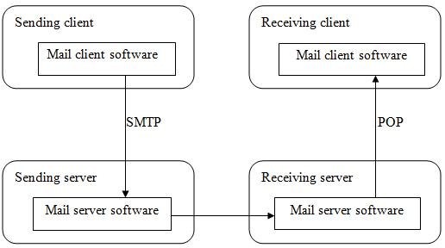

Figure 1. How email works.

2.8 MySQL

What is MySQL?
MySQL, the most popular Open Source SQL database management system, is developed, distributed, and supported by Oracle Corporation.
The MySQL website (http://www.mysql.com/) provides the latest information about MySQL software.
• MySQL is a database management system.
A database is a structured collection of data. It may be anything from a simple shopping list to a picture gallery or the vast amounts of information in a corporate network. To add, access, and process data stored in a computer database, you need a database management system such as MySQL Server. Since computers are very good at handling large amounts of data, database management systems play a central role in computing, as standalone utilities, or as parts of other applications.
- MySQL databases are relational.
A relational database stores data in separate tables rather than putting all the data in one big storeroom. The database structures are organized into physical files optimized for speed. The logical model, with objects such as databases, tables, views, rows, and columns, offers a flexible programming environment. You set up rules governing the relationships between different data fields, such as one-to-one, one-to-many, unique, required or optional, and “pointers” between different tables. The database enforces these rules, so that with a well-designed database, your application never sees inconsistent, duplicate, orphan, out-of-date, or missing data.
The SQL part of “MySQL” stands for “Structured Query Language”. SQL is the most common standardized language used to access databases. Depending on your programming environment, you might enter SQL directly (for example, to generate reports), embed SQL statements into code written in another language, or use a language-specific API that hides the SQL syntax.
SQL is defined by the ANSI/ISO SQL Standard. The SQL standard has been evolving since 1986 and several versions exist. In this manual, “SQL-92” refers to the standard released in 1992, “SQL:1999” refers to the standard released in 1999, and “SQL:2003” refers to the current version of the standard. We use the phrase “the SQL standard” to mean the current version of the SQL Standard at any time.
- MySQL software is Open Source.
Open Source means that it is possible for anyone to use and modify the software. Anybody can download the MySQL software from the Internet and use it without paying anything. If you wish, you may study the source code and change it to suit your needs. The MySQL software uses the GPL (GNU General Public License), http://www.fsf.org/licenses/, to define what you may and may not do with the software in different situations. If you feel uncomfortable with the GPL or need to embed MySQL code into a commercial application, you can buy a commercially licensed version from us. See the MySQL Licensing Overview for more information (http://www.mysql.com/company/legal/licensing/).
• The MySQL Database Server is very fast, reliable, scalable, and easy to use.
If that is what you are looking for, you should give it a try. MySQL Server can run comfortably on a desktop or laptop, alongside your other applications, web servers, and so on, requiring little or no attention. If you dedicate an entire machine to MySQL, you can adjust the settings to take advantage of all the memory, CPU power, and I/O capacity available. MySQL can also scale up to clusters of machines, networked together.
MySQL Server was originally developed to handle large databases much faster than existing solutions and has been successfully used in highly demanding production environments for several years. Although under constant development, MySQL Server today offers a rich and useful set of functions. Its connectivity, speed, and security make MySQL Server highly suited for accessing databases on the Internet.
• MySQL Server works in client/server or embedded systems.
The MySQL Database Software is a client/server system that consists of a multithreaded SQL server that supports different back ends, several different client programs and libraries, administrative tools, and a wide range of application programming interfaces (APIs). We also provide MySQL Server as an embedded multithreaded library that you can link into your application to get a smaller, faster, easier-to-manage standalone product.

Java Script
JavaScript is a programming language that allows scripting of events, objects, and actions to create Internet applications. A website development environment that will allow the creation of Interactive Web Pages. The coding techniques capable of accepting a client's requests and processing these requests.
The web site development environment should also provide the facility for 'validating' user input. With JavaScript, forms are a consideration in nearly every page you design. Capturing user requests is traditionally done via a 'form'. So the web site needs to have facilities to create forms. Text fields and text areas can dynamically change in response to user responses.
TOMCAT 5.0
Tomcat is a servlet container and Java Server Pages implementation it may be used stand alone ,or in conjunction with several popular web servers .
  - Apache version 1.3 or later
  - MS Internet Information Server ,version 4.0 or later
  - MS personel web server, version 4.0 or later
  - NetScape enterprise server , version 3.0 or later
Tomcat is a security update release. This release closes a whole that potentially allowed access to resources protected by a <security constraint > in web.xml.
Installing and Running Tomcat 5.0
Tomcat requires a Java Runtime Environment (JRE).Conformant to JRE 1.1 or later including any Java2 platform system. If one wishes to develop applications you will need a java compiler, such as the one included in a java development kit 1.1 or later environment including JDKs conformant with Java2.

2.4 HTML and CSS

HTML stands for Hyper Text Markup Language. It is used as the standard markup language for building web applications and web pages. It was originally developed by Tim Berners-Lee in 1991. HTML5 is the latest version of HTML. /8/

CSS stands for Cascading Style Sheet. It is used to style web pages for different kinds of devices and screen sizes. It also saves a lot of time and stress since it can be used to style multiple web pages simultaneously. Its latest version is CSS3. /9/

2.10 Eclipse IDE

Eclipse is an open source integrated development environment (IDE) for developing applications in Java and other languages like C++, JavaScript, PHP and C. It is written in Java, and it is the most commonly used IDE for Java applications. Examples of Eclipse development environment are Eclipse IDE for Java, Eclipse PDT for PHP and Eclipse CDT for C/C++. The latest release of Eclipse is Eclipse Oxygen, which was released in June 2017. /13/

2.11 Apache Tomcat

The Apache Tomcat is an open source web server and servlet container developed and released by the Apache Software Foundation (ASF). It is an implementation of Java Servlet, JavaServer Pages, Java Expression Language and Java WebSocket technologies. Its latest version is Tomcat 8.0.45. /14/

2.12 Apache POI

Apache POI (Poor Obfuscation Implementation) is a Java API for reading and writing Microsoft Excel files using Java programs. Also, it is utilized for reading and writing Microsoft Word and Microsoft PowerPoint files using Java. It supports different file formats, such as xsl, xlsx and docx. It is an open source API developed and released by ASF. /15/

2.13 Paytm Gateway

A payment gateway is a merchant service provided by an e-commerce application service provider that authorizes credit card or direct payments processing for e-businesses, online retailers, bricks and clicks, or traditional brick and mortar.[1] The payment gateway may be provided by a bank to its customers, but can be provided by a specialised financial service provider as a separate service, such as a payment service provider.
A payment gateway facilitates a payment transaction by the transfer of information between a payment portal (such as a website, mobile phone or interactive voice response service) and the front end processor or acquiring bank.

3 ANALYSIS AND REQUIREMENTS

Requirements analysis is one of the major tasks in software engineering, which is vital to the success of a software development project. It involves the determination of the requirements or functions of a software project . The main task to perform before analysing requirements is requirements elicitation
Requirements elicitation is the gathering of the requirements or needs of a software system from the client and other stakeholders involved in the software project. Some of the activities involved in requirements elicitation are interviews, meetings, and surveys. Three requirements elicitation techniques are Initiating the Process, Facilitated Application Specification Techniques (FAST), and Quality Function Deployment (QFD).
The requirements for this application were gathered based on QFD. This is because QFD prioritizes both explicit and implicit requirements for the software. Also, it focuses on client satisfaction all through the development process.

3.1 Application Description
This application is divided into two parts – the home page and the admin page. The home page is where customers (buyers) can order and pay for products, and optionally subscribe to an email list while the admin page is where the admin can carry out administrative tasks. The admin page is restricted and can only be accessed through authentication provided by the Apache Tomcat servlet container. This means that all the web resources in the admin page can only be accessed by an authorized user.

3.2 Quality Function Deployment (QFD)
QFD is a requirements elicitation technique used to convert client’s requirements and expectations into technical requirements for the software product. It aims at building a software system that fulfils client satisfaction by focusing on what is relevant to the client. More so, it utilizes different methods, such as interviews, surveys, and review of historical data to achieve its objectives.
According to user needs and expectations, QFD prioritizes requirements into three types
– They are:
- Normal requirements – These are must have requirements with priority level 1. They are requirements that fulfil client satisfaction if present.
- The home page of the application should display available products.
- Customers should be able to add products to a shopping cart.
- Customers should be able to view products in the shopping cart.
- Customers should be able to update product quantity in the cart.
- Customers should be able to remove any product from the cart.
- Customer should be able to empty all the products in the cart.
- Customers should have an option to subscribe to an email list.
- Customers should be able to checkout through PayPal Express Checkout payment solution on Paypal Sandbox.
- Customers should be able to view order confirmation after a successful order completion.
- The admin should be authenticated in order to have access to the admin page of the application to perform any administrative task.
- The admin should be able to manage (add, update and delete) products and their categories.
- The admin should be able to view the lists of products and categories.
- The admin should be able to view the email subscribers’ list.
- The admin should be able to view payment and order details.
- The admin should be able to update order status.
- The application should save all customer, product, order, payment and admin data on MySQL database.

- Expected requirements – These are should have requirements with priority level.
They are requirements that are not explicitly declared by the client but could be a reason for customer dissatisfaction if not accomplished.

- The application should display a friendly error message after failed login.
- The application should display a friendly error message after a failed or cancelled payment process.
- The application should implement interactive graphical user interfaces (GUI).
- An email confirmation should be sent to customers who subscribe to the email list.
- An email confirmation should be sent to customers after a successful order completion.
- The admin should be able to download email subscribers’ list, payments and orders reports in MS excel format.

- Exciting requirements – These are nice to have requirements with priority level
They are needs that are beyond the scope of the project but could result in client satisfaction when present.

- The application should implement other payment methods, such as debit/credit card and Google checkout.
- The application should also be available on mobile devices.

3.3 ANALYSIS MODELS

Modelling involves the designing of software systems before coding takes place. Modelling plays an important role in any software development project. It guarantees the completeness and correctness of a software system and the fulfilment of end-users’ expectations. In addition, modelling serves as the only reference point to cross-check requirements before coding.

A Unified Modelling Language (UML) based tool was used to model this application. UML diagrams give both static and dynamic views of an application and it is well suited for object-oriented languages like Java and C#. The following sub-sections present the UML diagrams used to model this application.

3.3.1 Use Case Diagram

The use case diagrams for this application illustrate the interactions that exist between users (actors) and use cases (actions) within the application. There are two actors identified for this application – administrator (admin) and customer actors. As a result, there are two use case diagrams for the software application – admin use case diagram and customer use case diagram. The admin is the owner of the e-commerce store who performs various administrative tasks such as add products, view orders, and update order status while the customer is any individual who buys a product or products from the online store.

Figure 2 shows the admin use case diagram. The diagram depicts how the admin communicates with the application. More so, it shows all the actions that the admin can perform on the application. As can be seen in the diagram, before any of these actions could be executed the admin will have to login in order to be authenticated.
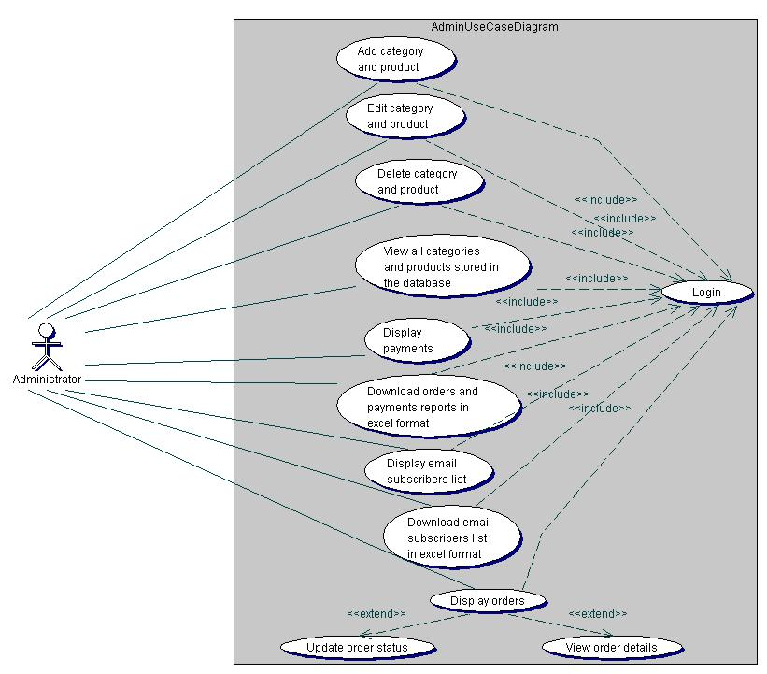

Figure 2. Admin use case diagram.

Figure 3 shows the customer use case diagram. It describes the different use cases that can be executed by the customer on the e-commerce application. For the checkout process using PayPal Express Checkout, the buyer will have to be authenticated on a secured PayPal website.
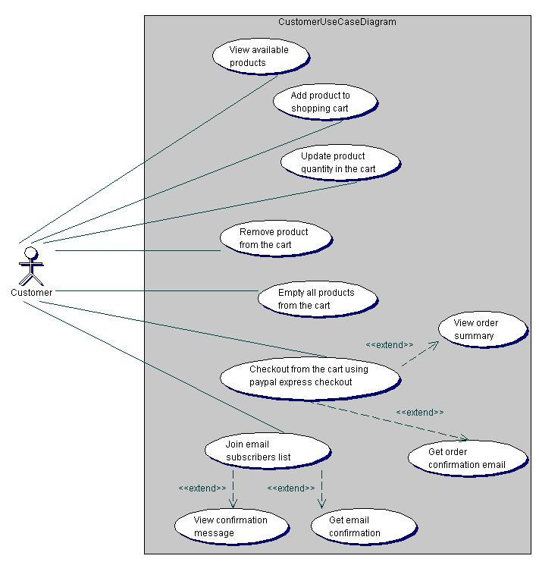

Figure 3. Customer use case diagram.

3.3.2 Class Diagram

A class diagram depicts the classes in a software system and how they interact with each other. Also, the class attributes and functions are illustrated in a class diagram. Figure 4 shows the class diagram for this application. It shows the relationships between classes in the application and constraints applied to these relationships.

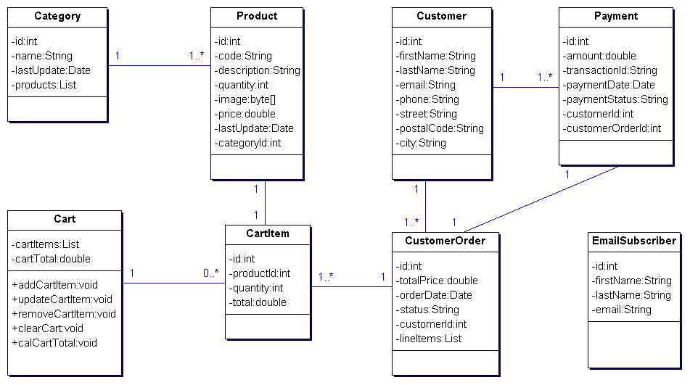

Figure 4. Class diagram.

3.3.3Sequence Diagram
A sequence diagram gives a detailed visual description of how the various classes in a system interact with each other. Also, it depicts the order in which different objects exchange messages with one another in a system. The sequence diagrams for this application are presented in the following sub-sections.

3.3.3.1 Admin Login Sequence Diagram
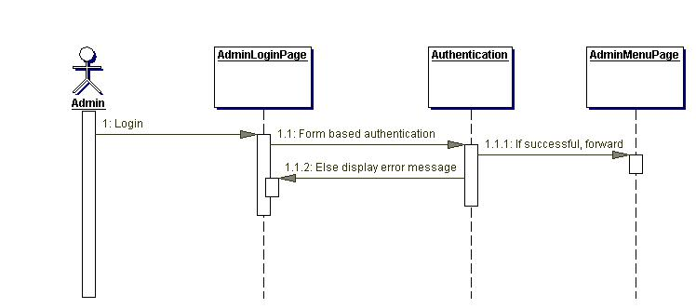
Figure 5 gives a detailed sequence of events needed for the admin to login to the admin page of the application. After providing the login credentials on the admin login page, the admin is authenticated through a form-based authentication method provided by the Apache Tomcat web server. After a successful authentication process, the admin is forwarded to the admin menu page, which contains links to several administrative functions. However, if the authentication process fails, the admin is redirected to the admin login page with displayed error message. For the remaining sequence diagrams required for the administrative tasks, see Appendices.

Figure 5. Admin login sequence diagram.

3.3.3.2 Order Sequence Diagram

The order sequence diagram is shown in Figure 6 below. On the home page of the application where all available products are displayed, the customer clicks the add product to cart link in order to add a product to the shopping cart. Then, the application returns the customer to the home page either to add more products to the cart or to view the shopping cart page. If the customer clicks the display shopping cart link, the shopping cart page is displayed. The shopping cart page contains all the line items in the cart and it is where the buyer can increase a line item quantity, remove a line item from the cart, and empty the entire cart line items. If the buyer performs any of these activities in the shopping cart, the application returns to the shopping cart to show the necessary updates in the shopping cart. If the customer clicks the continue shopping link on the shopping cart page, he/she is redirected to the home page of the application.

Furthermore, if the shopping cart is not empty and the buyer clicks the checkout with PayPal link, he/she is forwarded to the PayPal login page. On the PayPal login page, the customer login with his/her PayPal account credentials. If the login was successful, the customer is forwarded to PayPal order summary page, which shows summary information of all the ordered products, including the total price of the order. Otherwise, the buyer is redirected to PayPal login page to show an appropriate error message. On the PayPal order summary page, the customer clicks the continue link and is forwarded to the application’s order review page where he/she can access the complete order link. Now, when the buyer clicks the complete order link, the database handler retrieves customer, order and payment data. The handler updates the customer data on the database if the customer data already exists otherwise, it writes the data to the database. The handler also writes the order and payment data to the database.

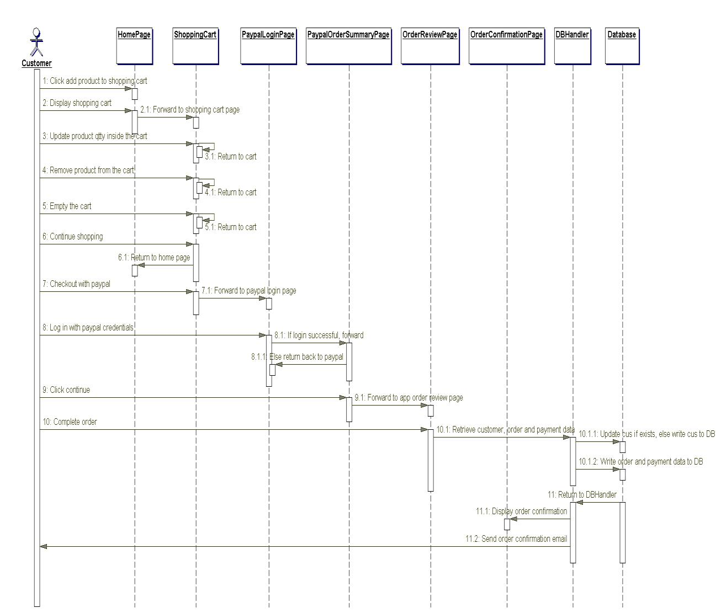
Lastly, after the handler performs the necessary operations on the database, the customer is redirected to the order confirmation page to display order confirmation message. Also, an e-mail confirmation is sent to the customer.
Figure 6. Order sequence diagram.
3.3.4 Component Diagram
A component diagram is used to depict the organizations of software components and the relationships that exist among them. Figure 7 illustrates the component diagram for this web application. It was modelled according to the Model-View-Controller (MVC)
pattern used for structuring web applications. The MVC pattern makes coding, testing and maintenance of an application easier and it is usually considered as a best practice.

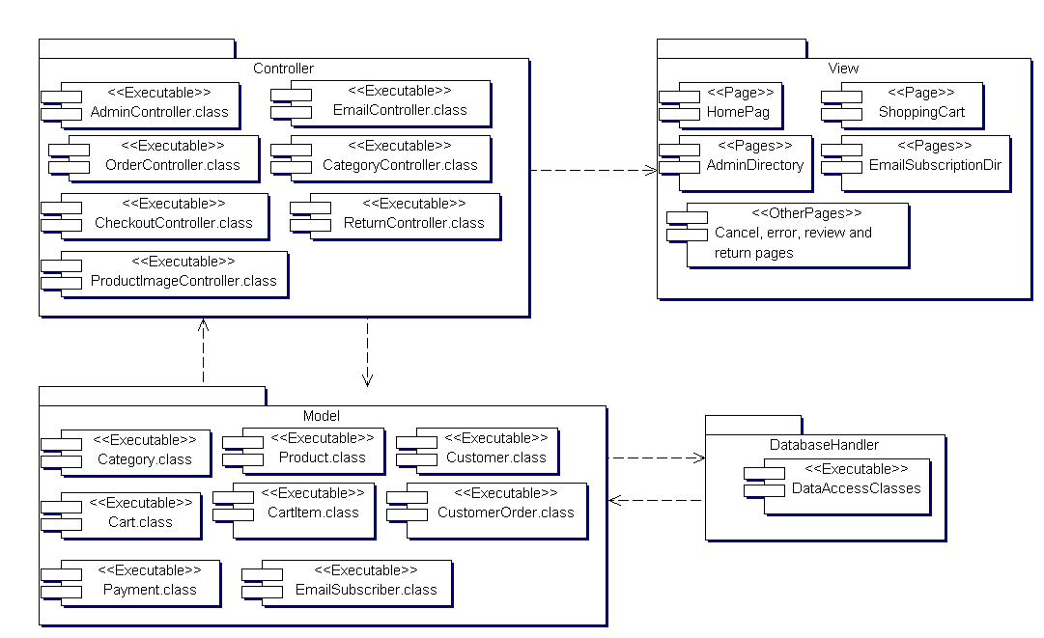
As can be seen in Figure 7, the MVC pattern divides this application into three distinct layers: the model, the view, and the controller. The model is the business layer of the application, which contains the JavaBeans for the application. A JavaBean is simply a plain old Java object (POJO) used to encapsulate data. The view represents the presentation layer, which contains JSP files for displaying the various pages of the application. The controller controls the flow of data between the model and the view. It contains servlets for updating the model object and saving it to the database through the database handler. The servlets also update the view for presentation when necessary. In addition, the database handler consists of data access classes, which provide methods for storing data in the database since the JavaBeans do not provide these methods.

Figure 7. Component diagram.

3.3.5 Deployment Diagram

The deployment diagram for this application is illustrated in Figure 8. The diagram shows the configuration of the run-time hardware components (nodes) and the software components running on those nodes. As can be seen in Figure 8, to deploy this web
application a database server, an application server, and computers with internet access are needed. Also, backup servers are provided for the database and application servers.
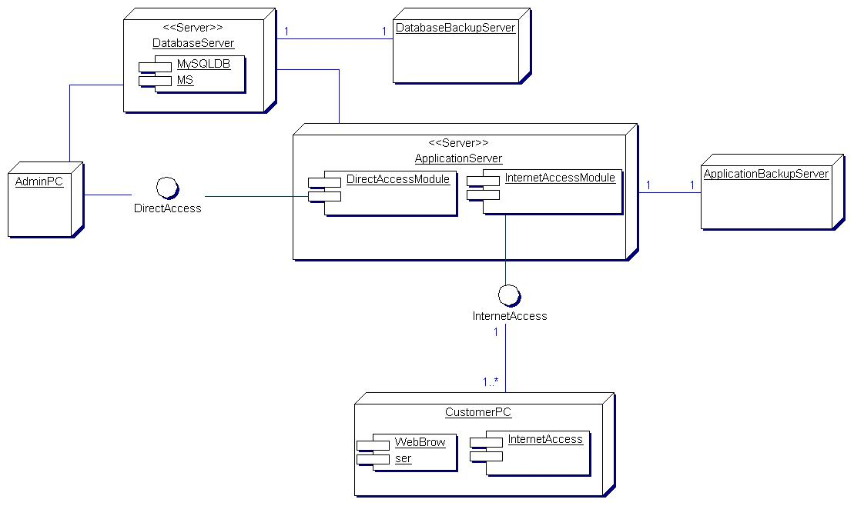

Figure 8. Deployment diagram.

4 DATABASE AND GUI DESIGN

Every web application needs to have an operational database to store its generated data. More so, a simple and interactive Graphical User Interface (GUI) is one of the success indicators of any web application project. This chapter presents the database and GUI design for this e-commerce application.

4.1 Database Design

MySQL database management system is the most popular database system for Java web applications because of its speed, reliability, and flexibility. All the data generated by this application are managed on MySQL database system. Figure 9 shows the Entity Relationship Diagram of the application database. All the tables (except admin and admin_roles) were generated by JPA based on the relationships that exist among the JPA entities defined for the application, and these relationships are clearly evidenced in the ER diagram. The admin and admin_roles tables were defined for authentication purpose. The following numbered list gives a brief explanation of these tables.

- Category – Contains category data for the products.
- Product – Contains product data.
- Customer – Contains customer data.
- Customer_order – Contains customer order information.
- Order_line_item – Contains order line items information.
- Customer_order_order_line_item – This is a bridge table automatically generated as a result of the one-to-many relationship that exists between customer_order and order_line_item tables.
- Payment – This contains order payment data.
- Sequence – Contains data used to automatically generate primary key values.

- Email_subscriber – Contains email subscribers information.
- Admin – Contains the administrator credentials for login (authentication) purpose.
- Admin_roles – Contains roles data of admin.
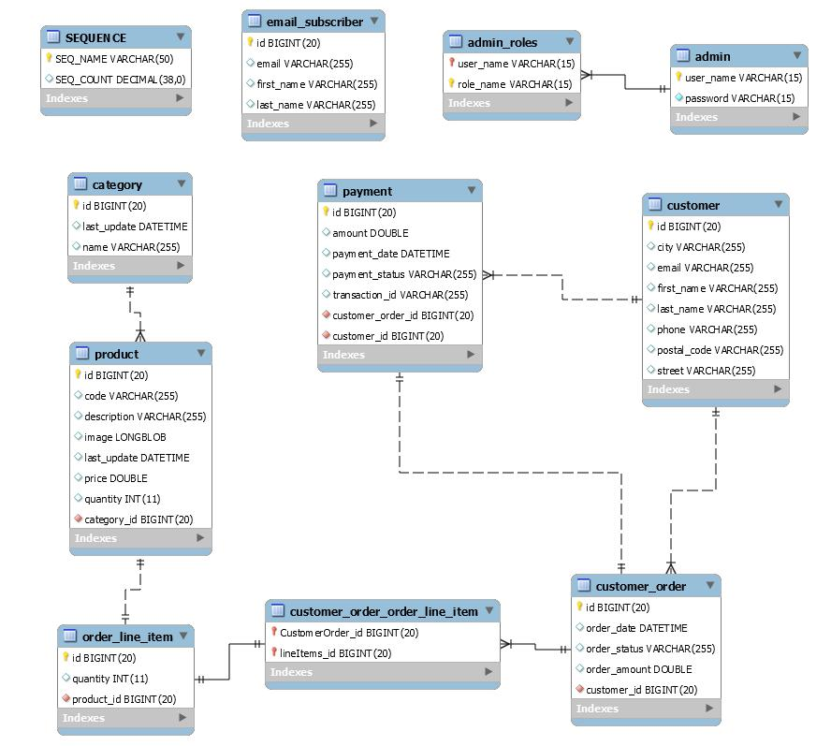

Figure 9. ER diagram.

4.2 GUI Design
The user interfaces for this e-commerce web application were designed using HTML and CSS. Also, some elements of HTML5 were used in designing the interfaces. The following subsections present the descriptions of these interfaces.

4.2.1 Home Page
The home page of this application is shown in Figure 10. It is the start page of the application where all available products with a quantity greater than zero are displayed. Also, customers or visitors to the e-commerce store can browse available products by category. On this page, customers can add products to the shopping cart, and there is a link provided to view products added to the shopping cart. More so, a link is provided
for customers and visitors to display and fill the email subscription form in order to subscribe to an email list for special announcements and offers.

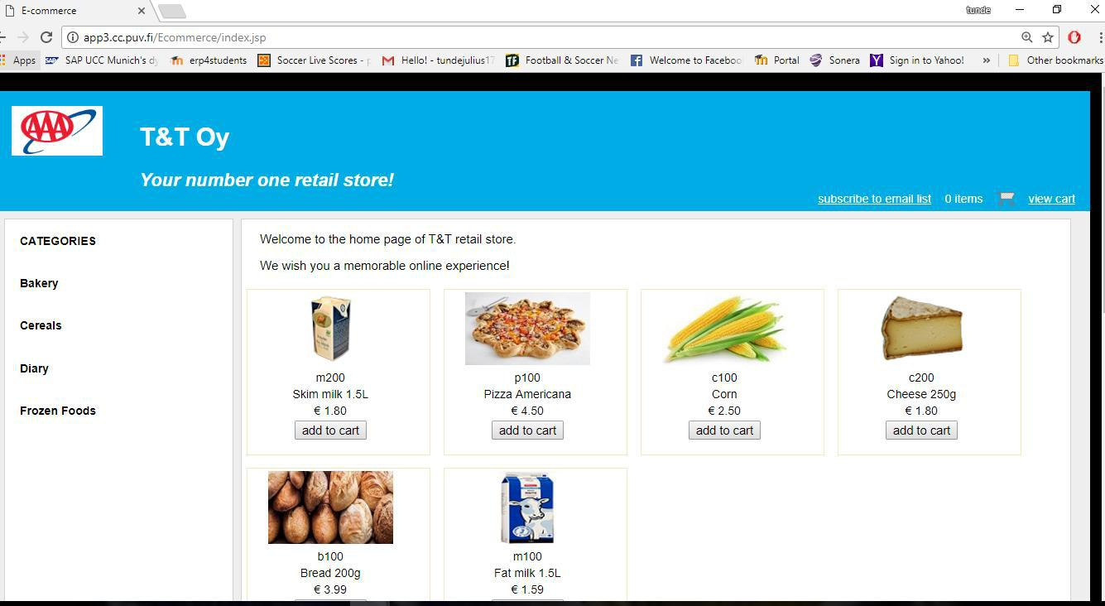

Figure 10. Home page.

4.2.2 Shopping Cart Page

The shopping cart page of this online store application is as shown in Figure 11. This page is accessed when a user clicks the view cart link to show the information of all the products added to the shopping cart. On this page, the quantity of any product in the cart can be changed and updated. Any product can be removed from the cart and the cart can be emptied as well. There are links provided for browsing available products by category and also to return to the home page of the application. In addition, the PayPal check out button is displayed on this page if the shopping cart is not empty.
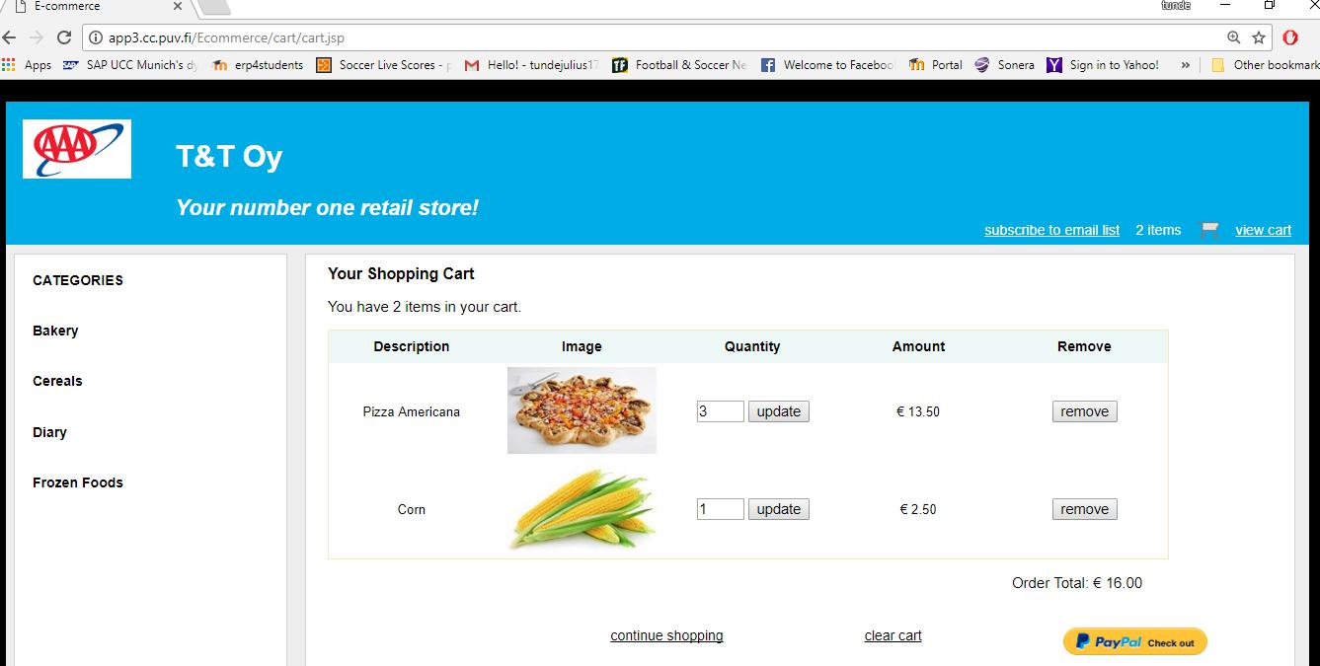

Figure 11. Shopping cart page.

4.2.3 Email Subscription Page

Figure 12 shows the email subscription page. This page is accessed when a user clicks the subscribe to email list link to display the email subscription form where a user can enter and submit the subscription information. The form does not accept null or empty values. After a successful subscription process, the user is redirected to a confirmation page which displays a confirmation message.
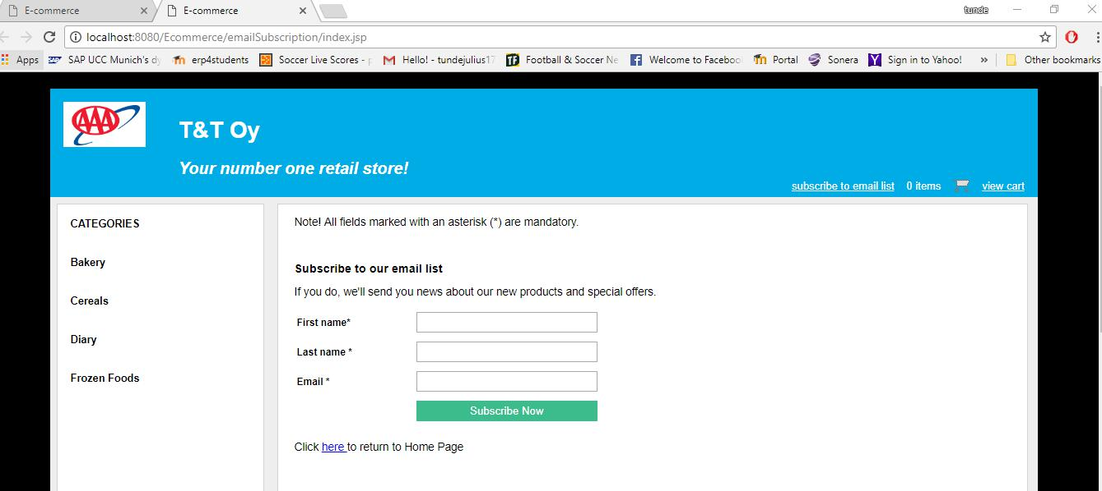

Figure 12. Email subscription page.

4.2.4 Order Review Page

The order review page of this application is as shown in Figure 13. This page shows an order review just before confirmation. It displays the customer’s shipping address, order amount, currency and payment status of the order. A button is provided to confirm the order.
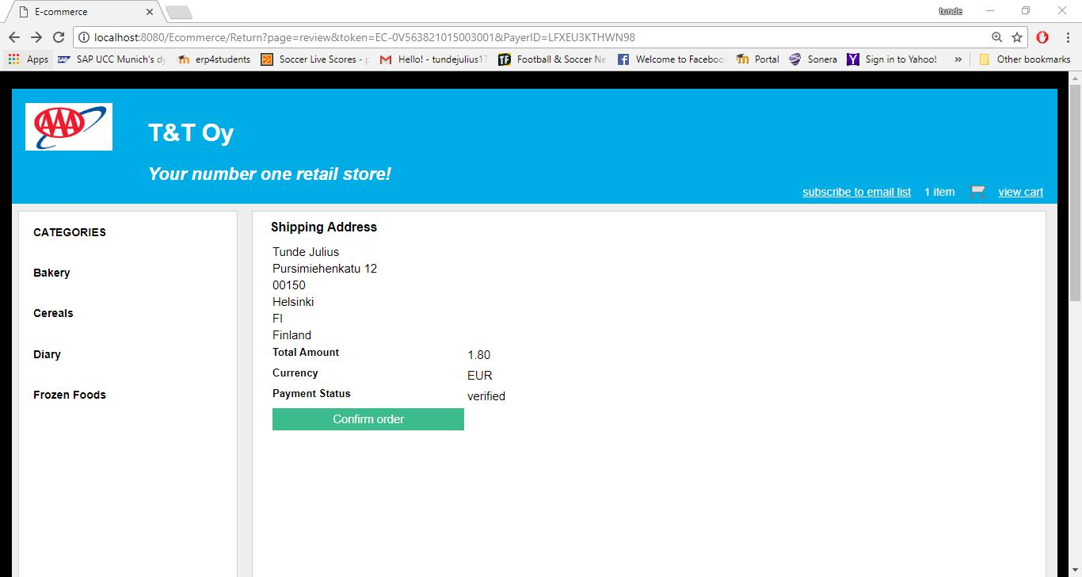

Figure 13. Order review page.

4.2.5 Order Confirmation Page

Shown in Figure 14 is the order confirmation page of this application. This page displays a confirmation message after a successful order process. It shows the customer’s shipping information and the details of the payment.
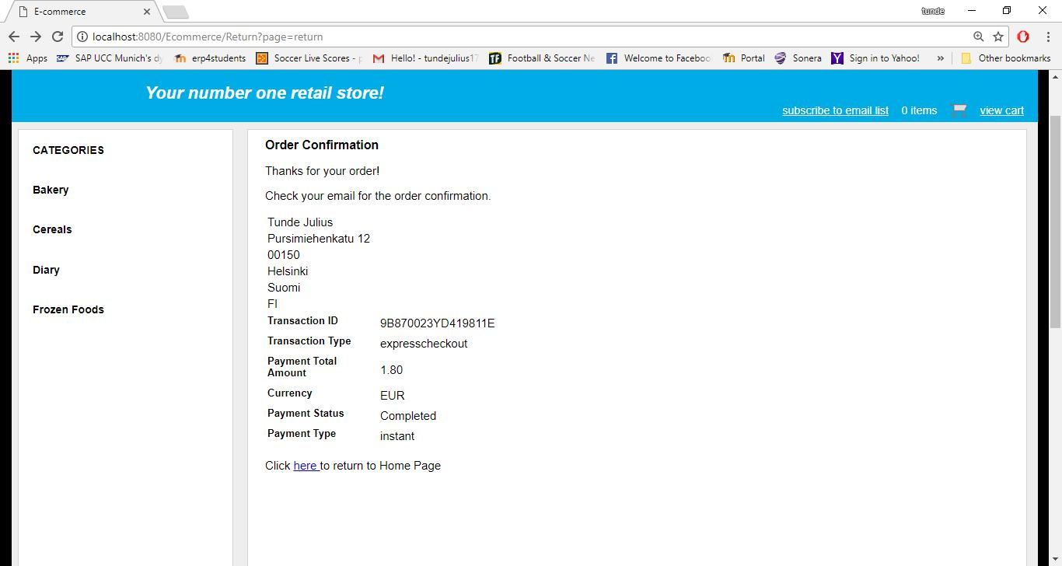

Figure 14. Order confirmation page.

4.2.6 Admin Login Page

Figure 15 shows the admin login page. This page presents the admin login form where a user can enter and submit login credentials for authentication purpose. It is actually a customized form for form-based authentication method provided by Apache Tomcat servlet container. More so, it is not possible to enter null or empty string values on the form. The page is displayed whenever a user tries to access the admin page of the application which is restricted and can only be accessed by authorized users. If the authentication fails the same page is displayed again but with an error message.
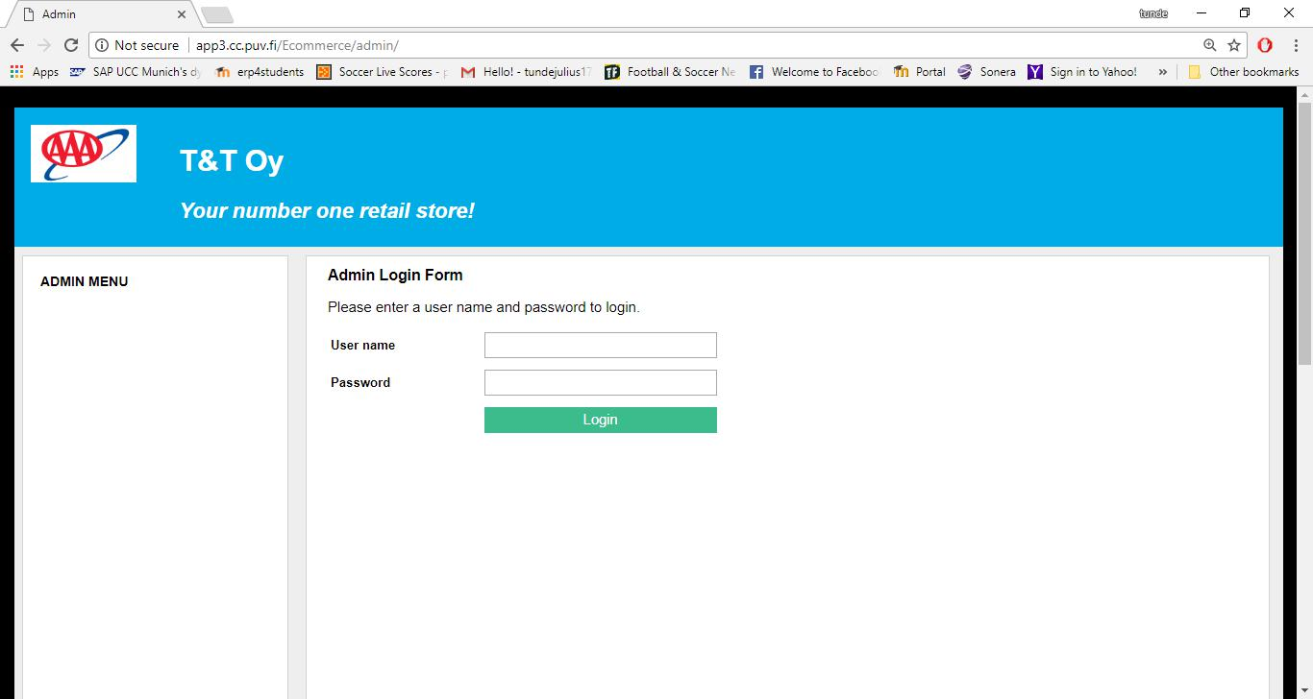

Figure 15. Admin login page.

4.2.7 Admin Menu Page

The admin menu page is shown in Figure 16 and it is displayed when a user has been successfully authenticated. The page is the gateway to the administrative tasks for the admin. The links for these tasks have been categorized so that they can be easily accessible.
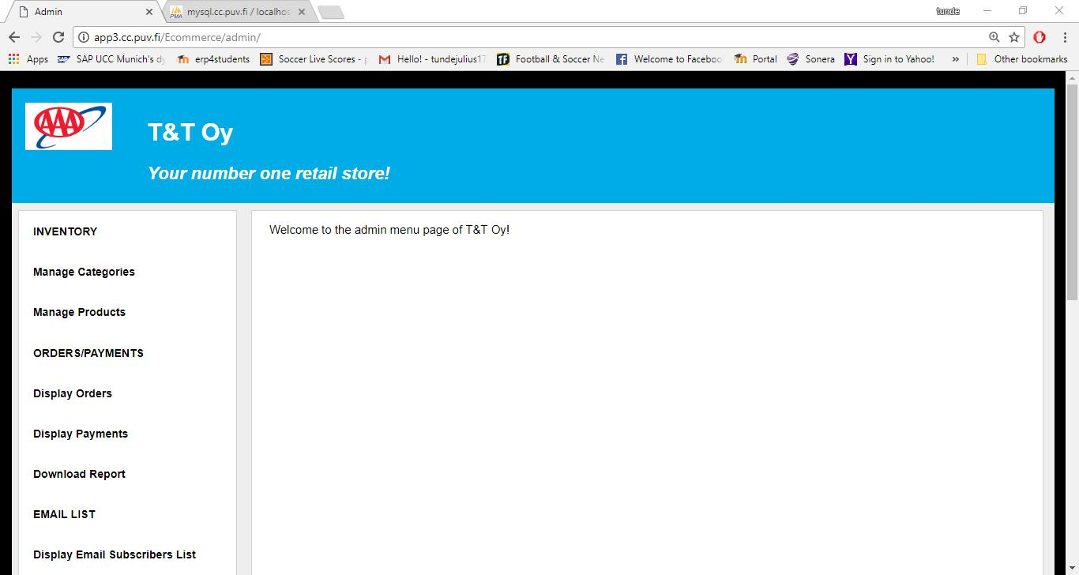

Figure 16. Admin menu page.

4.2.8 Categories Page

The categories page is the page for managing product categories for the e-commerce store, and it is accessed by clicking the manage categories link on the admin menu page. It is shown in Figure 17 below. All the product categories stored in the database are displayed on this page, and each of these categories has links for displaying all its products, editing its data and deleting it from the database. Also, at the top of the page there is a link for displaying a form for adding categories.
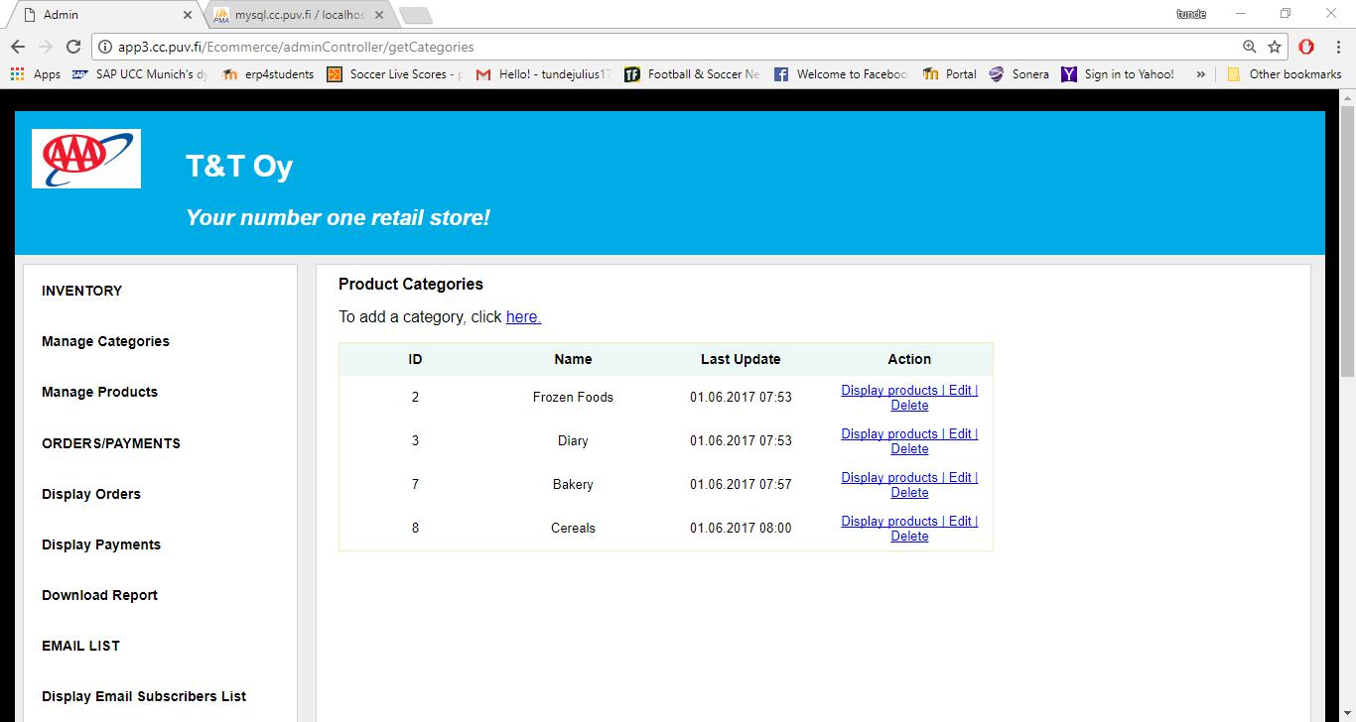

Figure 17. Categories page.

4.2.9 Add Category Page

The page for adding product categories is shown in Figure 18. The page displays the add category form when an admin user clicks the link for adding a category on the categories page. The form checks for null and empty string values, thus, it is not possible to enter null or empty string values. The edit category form is basically the same as the add category form, except that it contains editable data in its field.
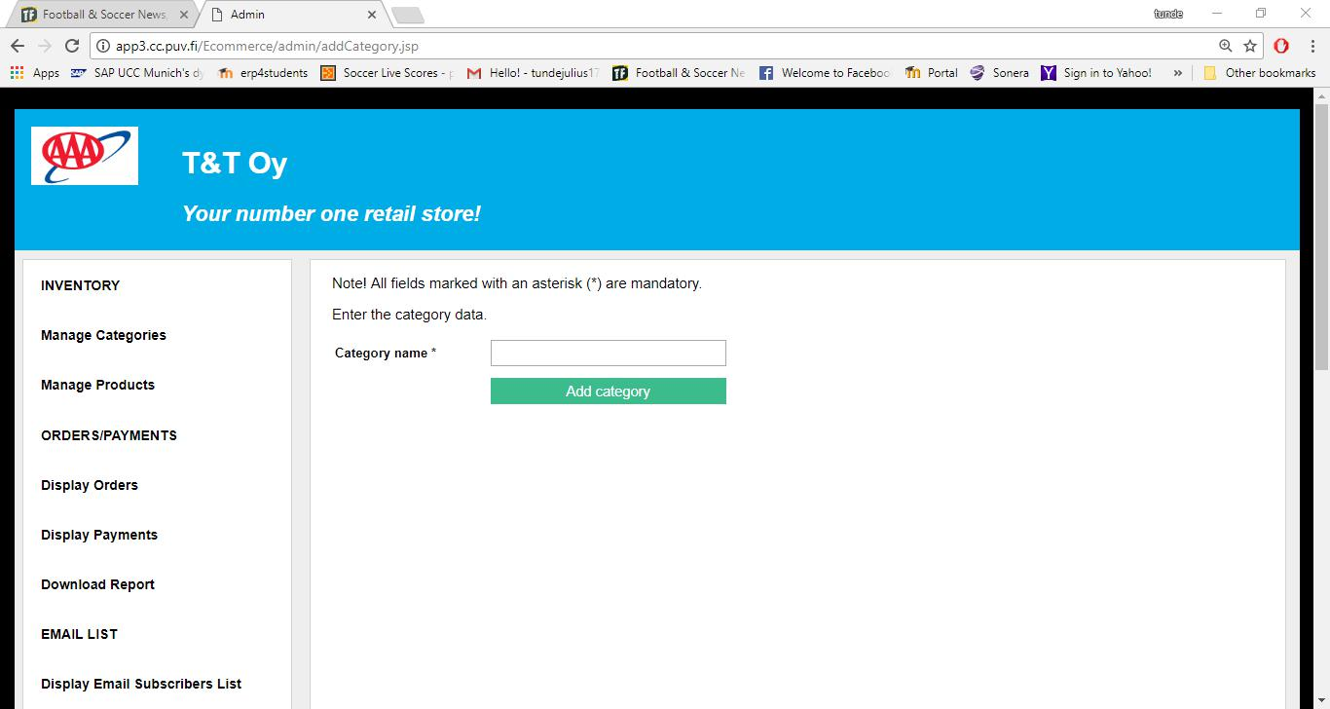

Figure 18. Add category page.

4.2.10 Products Page

Figure 19 shows the products page of this application. It is the page for managing products of the online store and is accessed by clicking the manage products link on the admin menu page. All products of the store are displayed on this page, and each of these products has links for editing its data and deleting it from the database. Also, at the top of the page there is a link for adding products.
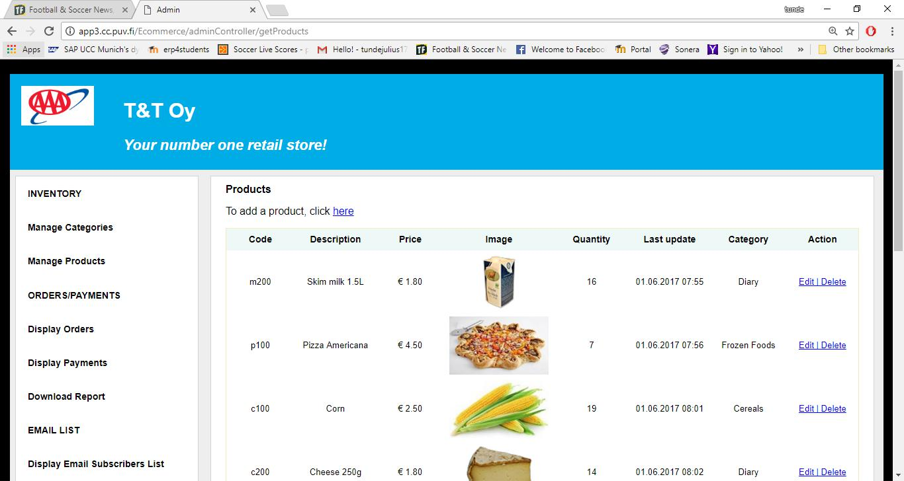

Figure 19. Products page.

4.2.11 Add Product Page

The page for adding products is shown in Figure 20. The form on this page is displayed when the link for adding products on the products page is clicked. Every input on this form is checked for null and empty values. The edit product form is basically the same as the add product form, except that it contains editable data in its fields.
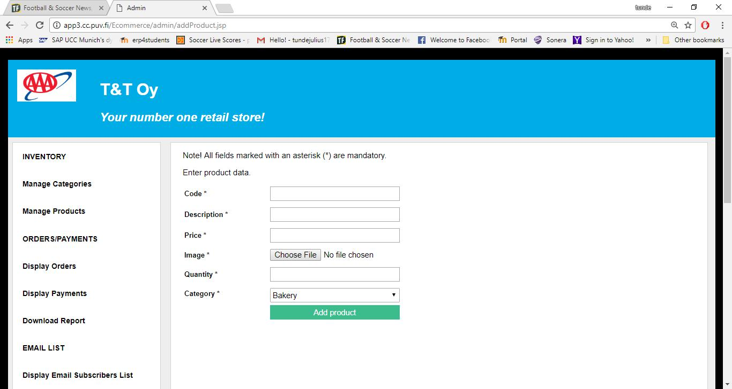

Figure 20. Add product page.

4.2.12 Email List Page

The email list page is shown in Figure 21. The page is accessed by clicking the display email subscribers list link on the admin menu page. It displays a list of all customers and visitors to the web store who have subscribed to the email list for special announcements and offers.
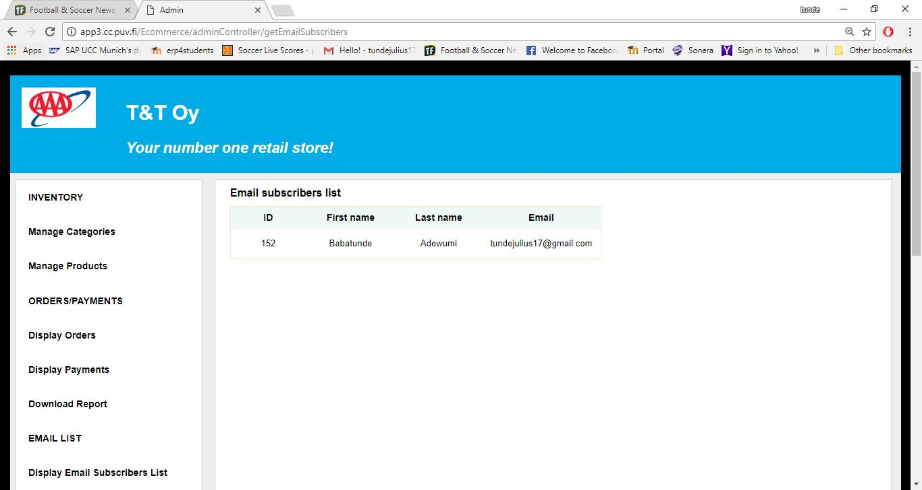

Figure 21. Email list page.

4.2.13 Report Download Form

Figure 22 shows the report download form, which is accessed by clicking the download report link on the admin menu page. The user chooses the report to be downloaded, enters start and end dates in the given format, and clicks the download button to download the chosen report in excel format. An appropriate error message is displayed if a wrong date format is entered.
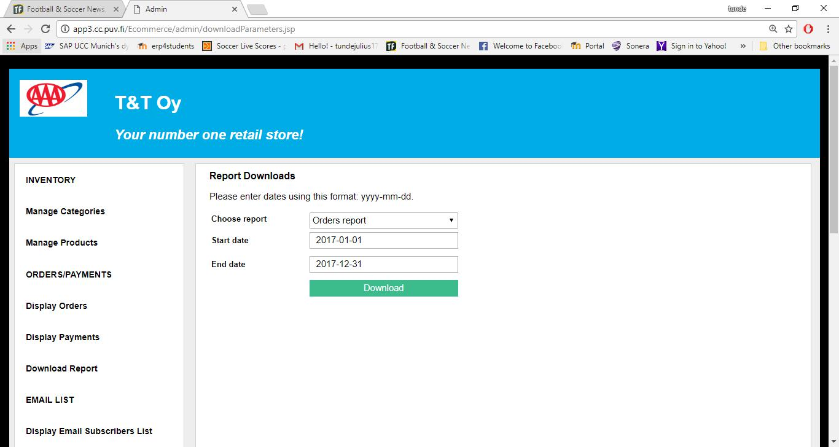

Figure 22. Report download form.

4.2.14 Orders List Page

The orders list page is shown in Figure 23. The page is displayed when an admin user fills and successfully submits the orders report form. The page displays a list of all orders requested in accordance with the start and end dates entered on the orders report form. Also, it is possible to view details of an order by clicking the view details button. Lastly, the status of the order can be updated on the order details page.
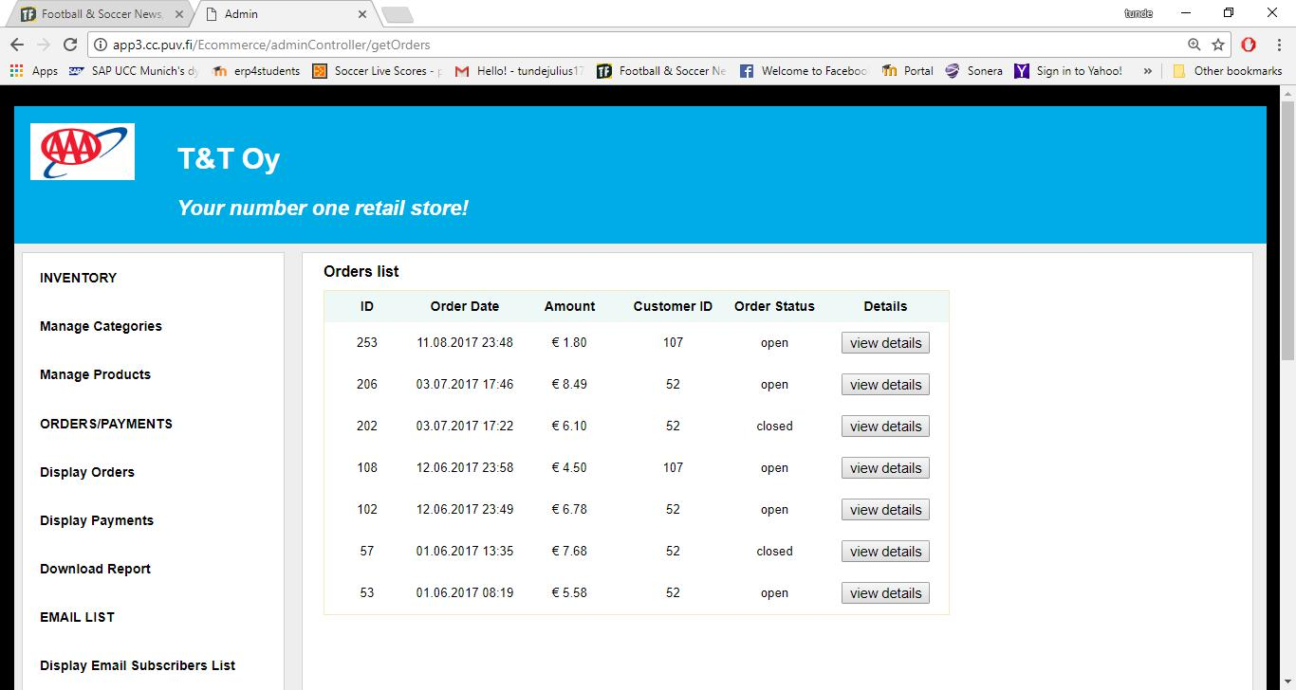

Figure 23. Orders list page.

4.2.15 Payments List Page

The diagram in Figure 24 is the payments list page of this online retail store application. The page is accessed by filling and submitting the payment report form correctly. The page displays a list of all payment transactions in accordance with the start and end dates entered.
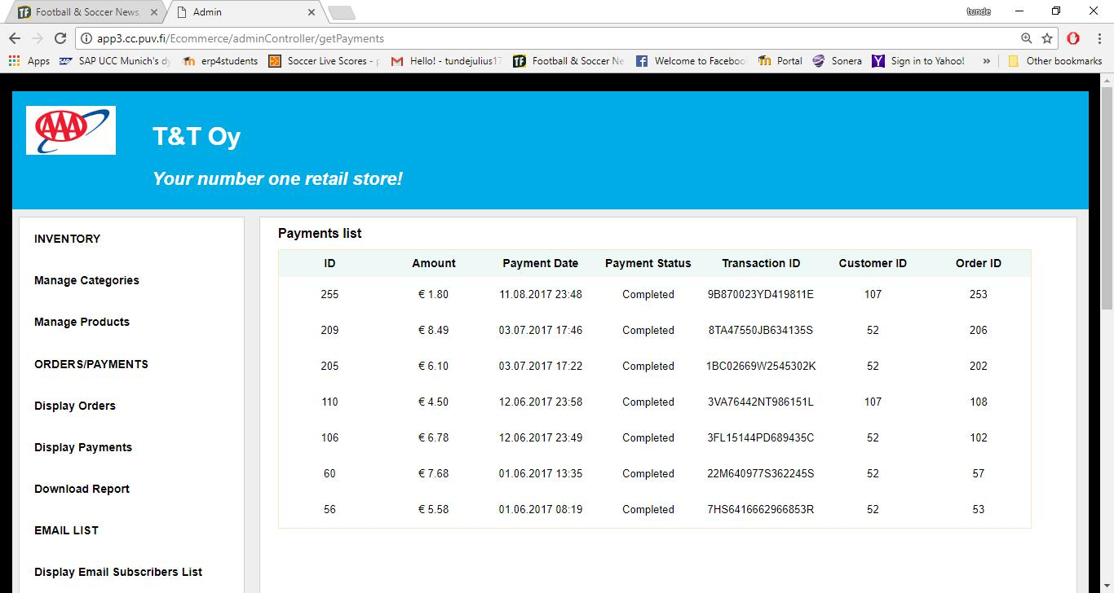

Figure 24. Payments list page.

5 IMPLEMENTATION

Implementation in software development is the process of realizing an application’s requirements and design. It mainly involves mapping the design into coding in order to achieve the specifications stated for the application. This section will describe the key implementation processes and some code snippets of this e-commerce web application.

This application was implemented as a JPA application, thus, the database tables used by the application were automatically generated by JPA. As earlier shown in the component diagram of Figure 7 of chapter 3, the application was structured according to the MVC pattern. This pattern aims to separate the user interface logic from the business logic. Also, this pattern helps to create well defined and organized web applications with efficient code reuse and multiple views.

5.1 Home Page

The home page of the application displays all the available products in the store. In Code Snippet 1, the getProducts helper method is called to retrieve all product data stored in the database. Also, shown in the code snippet is the implementation of the getProducts method, which calls the getEntityManagerFactory static method in order to establish a connection to the database.

List<Product> products = DBProduct.getProducts(); session.setAttribute("custProducts", products);

- This retrieves product objects from the database. public static List<Product> getProducts() {
EntityManager em = DBUtil.getEntityManagerFactory()
.createEntityManager();
String query = "SELECT p FROM Product p ORDER BY p.lastUpdate";
TypedQuery<Product> q = em.createQuery(query, Product.class);
List<Product> products;

try {
products = q.getResultList();
if (products == null || products.isEmpty())
products = null;
} finally {
em.close();
}
return products;
}

Code Snippet 1. Retrieving available products from the database.

5.2 Subscription to Email List

Code Snippet 2 shows the implementation of the subscribeToEmail method. This method retrieves the submitted input data on the subscribe to email form. It then checks that no input parameter is null or empty by calling the checkParam method. It also calls the checkEmail method to ensure that the user enters a valid email address. In order to avoid duplicate email address in the database, the emailExists method is called to check if the entered email address already exists in the database. The addEmailSubscriber method is called to add the entered data into the database if all the input parameters are entered correctly. Lastly, the sendEmail method is called to send an email confirmation to the provided email address and the user is redirected to the confirmation page.

// Insert EmailSubscriber obj into the database.

private String subscribeToEmail(HttpServletRequest request, HttpServletResponse response) throws IOException {

String firstName = request.getParameter("firstName").trim();
String lastName = request.getParameter("lastName").trim();

String email = request.getParameter("email").trim();

String message = "";

String url = "";

EmailSubscriber emailSubscriber = new EmailSubscriber();
emailSubscriber.setFirstName(firstName);

emailSubscriber.setLastName(lastName);

emailSubscriber.setEmail(email);

request.setAttribute("emailSubscriber", emailSubscriber);

if (!ValidatorUtil.checkParam(firstName)
  - !ValidatorUtil.checkParam(lastName)

  - !ValidatorUtil.checkParam(email)) { message = "No field can be empty"; request.setAttribute("message", message);

url = "/emailSubscription/index.jsp"; } else if (!ValidatorUtil.checkEmail(email)) {

request.setAttribute("emailError", "email not in the right format"); url = "/emailSubscription/index.jsp";

} else {// No two email address can be the same in the database. if (DBEmail.emailExists(email)) {
String emailMessage = "This email address already exist. "

- "<br> Kindly provide another email address.";

request.setAttribute("emailMessage", emailMessage); url = "/emailSubscription/index.jsp";

} else {

DBEmail.addEmailSubscriber(emailSubscriber);

- Prepare the confirmation email message String recipient = email;
String sender =

this.getServletContext().getInitParameter("custServEmailAddress");

String subject = "Email Subscription Confirmation";

String body = "<p>Hello "

- emailSubscriber.getFirstName()
- ",</p>\n\n"
- "<p>Thank you for subscribing to our email list."

  - " We will send you news about our new prod-

ucts and special offers.</p>\n\n"

- "<p>Sincerely, </p>\n" + "<p>T&T Team</p>\n\n";

boolean bodyIsHTML = true;

try {

// Send email message.

EmailUtil.sendEmail(recipient, sender, subject, body, bodyIsHTML);

} catch (MessagingException e) { e.printStackTrace();

}

url = "/emailSubscription/confirmation.jsp";

}

}

return url;

}

Code Snippet 2. Method for subscribing to the email list.

5.3 Add Product to the Shopping Cart

In Code Snippet 3, the addCartItem method is called when a user clicks the add to cart button on the home page of the application. In this method, a new instance of the Cart

class is created if the retrieved Cart object does not exist in the Session object. Then the addCartItem method of the Cart class is called to add the product to the shopping cart after all the necessary operations and checks. Lastly, the Cart object is saved into the Session object and the user is redirected back to the home page of the application.

// Add product to the shopping cart.

private String addCartItem(HttpServletRequest request, HttpServletResponse response) throws IOException {
HttpSession session = request.getSession();
Cart cart = (Cart) session.getAttribute("cart");
if (cart == null) {
cart = new Cart();
}
String code = request.getParameter("code");

if (!code.isEmpty()) {
Product product = DBProduct.getProductByCode(code);
cart.addCartItem(product);
}
session.setAttribute("cart", cart);
return "/index.jsp";

}

Code Snippet 3. Method for adding product to the shopping cart.

5.4 Update Item in the Shopping Cart

The updateCartItem method in Code Snippet 4 is responsible for updating the quantities of items in the shopping cart. The code and quantity parameters are first retrieved from the Request object, and the Cart object retrieved from the Session object. After all the necessary operations and checks, the updateCartItem method of the Cart class is called to perform the necessary updates in the shopping cart, including item quantity.

- Update cart item quantity in the shopping cart. private String updateCartItem(HttpServletRequest request,

HttpServletResponse response) throws IOException {

String code = request.getParameter("code");

String qtyString = request.getParameter("quantity");

HttpSession session = request.getSession();

Cart cart = (Cart) session.getAttribute("cart");

int quantity;

Product product = DBProduct.getProductByCode(code);

try {

quantity = Integer.parseInt(qtyString);

if (quantity < 0 || quantity == 0) {

quantity = 1;

}

if (quantity > product.getQuantity()) {

quantity = 1;

request.setAttribute("insuffientQuantity",

"insufficient quantity");

}

} catch (NumberFormatException ex) {

quantity = 1;

}

if (quantity < product.getQuantity()

- quantity == product.getQuantity()) { cart.updateCartItem(product, quantity);

}

return "/cart/cart.jsp";

}

Code Snippet 4. Method for updating item quantity in the shopping cart.

5.5 Remove Item from the Shopping Cart

The removeCartItem method in Code Snippet 5 is responsible for removing an item from the shopping cart. After performing all the necessary operations and checks it calls the removeCartItem method of the Cart class to remove the item from the cart.

// Remove cart item from the shopping cart

private String removeCartItem(HttpServletRequest request, HttpServletResponse response) throws IOException {
String code = request.getParameter("code");
HttpSession session = request.getSession();
Cart cart = (Cart) session.getAttribute("cart");
Product product = DBProduct.getProductByCode(code);
if (product != null && cart != null) {
cart.removeCartItem(product);
}
return "/cart/cart.jsp";
}

Code Snippet 5. Method for removing item from the shopping cart.

5.6 Remove all Items from the Shopping Cart

Code Snippet 6 shows the implementation of the clearCart method. It is responsible for removing all items from the shopping cart. It calls the clearCart method of the Cart class to delete all items from the cart after all the necessary operations and checks.

// Remove all items in the cart.

private String clearCart(HttpServletRequest request, HttpServletResponse response) throws IOException {
HttpSession session = request.getSession();
Cart cart = (Cart) session.getAttribute("cart");
if (cart != null) {
cart.clearCart();
}
return "/cart/cart.jsp";
}

Code Snippet 6. Method for removing all items from the shopping cart.

5.7 Payment with PayPal Express Checkout

This e-commerce web store uses PayPal Express Checkout as its payment solution. With this payment solution, the buyer does not enter any information as the buyer’s details can be obtained from PayPal. For the purpose of testing, this application uses a virtual testing environment called PayPal Sandbox, which mimics most of the features of the PayPal production environment. In order to use the Sandbox server, a seller (merchant) and a buyer test accounts were created. Three PayPal Name-Value Pair (NVP) API operations were created to implement the Express Checkout payment solution. The following subsections describe these API operations.

5.7.1 SetExpressCheckout API Call

Code Snippet 7 shows the method used to implement the SetExpressCheckout API call. This API call is used to initiate the payment transaction. When a buyer clicks the PayPal check out button on the shopping cart page of the application, the callShortcutExpressCheckout method is called. The checkoutDetails parameter of the method contains the request-specific fields retrieved from the clicked button. The returnURL parameter is the page on the e-commerce web store that PayPal redirects to after a successful payment authorization, and the cancelURL is the page on the e-commerce web store that PayPal redirects to if a buyer cancels the payment. From the method implementation, the fields in the checkoutDetails parameter are used to construct an NVP string, and then an HTTP POST request is sent to PayPal API server by calling the httpCall method, which makes the SetExpressCheckout API call. Part of the response to the API call is an acknowledgment status, which indicates a success or failure with or without warning messages. Also, a token is returned as part of the
52

response. The token is a unique string used for identifying each transaction and in making other API calls.

//Method for implementing the SetExpressCheckout API call.

public Map<String, String> callShortcutExpressCheckout(

Map<String, String> checkoutDetails, String returnURL, String cancelURL) {

- Construct the parameter string that describes the

- SetExpressCheckout API call

StringBuilder nvpstr = new StringBuilder("");

//Append the line item parameters to the nvpstr variable.

for (String key : checkoutDetails.keySet()) {

if (key.startsWith("L")) {

nvpstr.append("&" + key +

"=").append(checkoutDetails.get(key));

}

}

if (isSet(checkoutDetails.get("PAYMENTREQUEST_0_AMT"))) { nvpstr.append("&PAYMENTREQUEST_0_AMT=").append(
checkoutDetails.get("PAYMENTREQUEST_0_AMT"));

}

if (isSet(checkoutDetails.get("paymentType"))) { nvpstr.append("&PAYMENTREQUEST_0_PAYMENTACTION=").append(
checkoutDetails.get("paymentType"));

}

if (isSet(returnURL))

nvpstr.append("&RETURNURL=").append(returnURL);

if (isSet(cancelURL))

nvpstr.append("&CANCELURL=").append(cancelURL );

if (isSet(checkoutDetails.get("currencyCodeType"))) {

nvpstr.append("&PAYMENTREQUEST_0_CURRENCYCODE=").append(

checkoutDetails.get("currencyCodeType"));

}

if (isSet(checkoutDetails.get("PAYMENTREQUEST_0_ITEMAMT"))) { nvpstr.append("&PAYMENTREQUEST_0_ITEMAMT=").append(
checkoutDetails.get("PAYMENTREQUEST_0_ITEMAMT"));

}

if(isSet(checkoutDetails.get("LOGOIMG")))

nvpstr.append( "&LOGOIMG="+ checkoutDetails.get("LOGOIMG")); //Make the API call.

return httpCall("SetExpressCheckout", nvpstr.toString());

}

Code Snippet 7. Method for SetExpressCheckout API call.

5.7.2 GetExpressCheckoutDetails API Call

In Code Snippet 8, the getShippingDetails implements the GetExpressCheckoutDetails API call. In the method, an NVP string is constructed by using the token returned from the SetExpressCheckout API call. Then, a call is made to the GetExpressCheckoutDetails API by calling the httpCall method. The response of this API call contains the buyer’s details and an acknowledgment status, which indicates a success or a failure with or without warning messages.
53

//Method for implementing GetExpressCheckoutDetails API call. public Map<String, String> getShippingDetails(String token) {
//Construct the nvp string

String nvpstr = "&TOKEN=" + token;
//Make the API call.

return httpCall("GetExpressCheckoutDetails", nvpstr);

}

Code Snippet 8. Method for GetExpressCheckoutDetails API call.

5.7.3 DoExpressCheckoutPayment API Call

As shown in Code Snippet 9, the confirmPayment method implements the DoExpressCheckoutPayment API call, which completes the payment transaction. In this method, the NVP string is constructed with the necessary request-specific fields in the checkoutDetails parameter of the method. Then the API call is made by calling the httpCall method. The response from this API contains a success or a failure with or without warning messages, and other transaction specific information like transaction id.
54

//Method implementation for DoExpressCheckoutPayment API call.

public HashMap<String, String> confirmPayment(

Map<String, String> checkoutDetails, String serverName) { // Construct the NVP string
String finalPaymentAmount = encode(checkoutDetails

.get("PAYMENTREQUEST_0_AMT"));

StringBuilder nvpstr = new StringBuilder("");

- mandatory parameters in DoExpressCheckoutPayment call if (isSet(checkoutDetails.get("TOKEN")))

nvpstr.append("&TOKEN=").append(
encode(checkoutDetails.get("TOKEN")));

if (isSet(checkoutDetails.get("payer_id")))

nvpstr.append("&PAYERID=").append(

encode(checkoutDetails.get("payer_id")));

nvpstr.append("&PAYMENTREQUEST_0_SELLERPAYPALACCOUNTID=").append( this.getSellerEmail());

if (isSet(checkoutDetails.get("paymentType")))

nvpstr.append("&PAYMENTREQUEST_0_PAYMENTACTION=").append( encode(checkoutDetails.get("paymentType")));

if (isSet(serverName))

nvpstr.append("&IPADDRESS=").append(encode(serverName));

nvpstr.append("&PAYMENTREQUEST_0_AMT=").append(finalPaymentAmount);
- Check for additional parameters that can be passed in

- DoExpressCheckoutPayment API call

if (isSet(checkoutDetails.get("currencyCodeType")))

nvpstr.append("&PAYMENTREQUEST_0_CURRENCYCODE=").append(

encode(checkoutDetails.get("currencyCodeType").toString()));
if (isSet(checkoutDetails.get("PAYMENTREQUEST_0_ITEMAMT")))

nvpstr.append("&PAYMENTREQUEST_0_ITEMAMT=").append(

encode(checkoutDetails.get("PAYMENTREQUEST_0_ITEMAMT")

.toString()));

if (isSet(checkoutDetails.get("PAYMENTREQUEST_0_TAXAMT")))
nvpstr.append("&PAYMENTREQUEST_0_TAXAMT=").append(

encode(checkoutDetails.get("PAYMENTREQUEST_0_TAXAMT")

.toString()));

if (isSet(checkoutDetails.get("shippingAmt")))

nvpstr.append("&PAYMENTREQUEST_0_SHIPPINGAMT=").append(

encode(checkoutDetails.get("PAYMENTREQUEST_0_SHIPPINGAMT")

.toString()));

if (isSet(checkoutDetails.get("handlingAmt")))

nvpstr.append("&PAYMENTREQUEST_0_HANDLINGAMT=").append(

encode(checkoutDetails.get("PAYMENTREQUEST_0_HANDLINGAMT")
.toString()));

if (isSet(checkoutDetails.get("shippingDiscAmt")))

nvpstr.append("&PAYMENTREQUEST_0_SHIPDISCAMT=").append(

encode(checkoutDetails.get("PAYMENTREQUEST_0_SHIPDISCAMT")

.toString()));
if (isSet(checkoutDetails.get("insuranceAmt")))

nvpstr.append("&PAYMENTREQUEST_0_INSURANCEAMT=").append(

encode(checkoutDetails.get("PAYMENTREQUEST_0_INSURANCEAMT")

.toString()));

//Make the API call.
return httpCall("DoExpressCheckoutPayment", nvpstr.toString());

}

Code Snippet 9. Method for DoExpressCheckoutPayment API call.

5.8 Sending Email

Code Snippet 10 shows the method implementation for sending an email confirmation to users after completing an order or subscribing to an email list. The method uses methods and classes from the JavaMail API to automatically send email notifications.

//Method for sending email messages.

public static void sendEmail(String recipient, String sender, String subject, String body, boolean bodyIsHTML) throws MessagingException {
// Get a mail session
Properties properties = new Properties();
properties.put("mail.transport.protocol", "smtp");
properties.put("mail.smtps.host", "localhost");
properties.put("mail.smtps.port", 25);

Session session = Session.getDefaultInstance(properties); session.setDebug(true);
// Create a message
Message message = new MimeMessage(session);
message.setSubject(subject);
if (bodyIsHTML) {
message.setContent(body, "text/html");
} else {
message.setText(body);
}
// Here we set the addresses

Address fromAddress = new InternetAddress(sender); Address toAddress = new InternetAddress(recipient); message.setRecipient(Message.RecipientType.TO, toAddress); message.setFrom(fromAddress); Transport.send(message);

}

Code Snippet 10. Method for sending an email.

5.9 Admin Login

The admin login process was implemented by the form-based authentication method provided by Apache Tomcat container. Code Snippet 11 shows the authentication configuration. As can be seen from the Code Snippet, all web resources in the admin directory of the application are restricted and a user with manager role is being granted authorization to access the restricted resources. Lastly, customized login and error pages are defined for the authentication.
56

<security-role>
<description>owner</description>

<role-name>manager</role-name>
</security-role>
<security-constraint>

<!-- Restrict access to the URLs in the admin directory --> <web-resource-collection>

<web-resource-name>Admin</web-resource-name>
<url-pattern>/admin/*</url-pattern>
</web-resource-collection>
<!-- Authorize the service and programmer roles -->

<auth-constraint>
<role-name>manager</role-name>

</auth-constraint>
</security-constraint>

<!-- Use form-based authentication to provide access --> <login-config>
<auth-method>FORM</auth-method>
<form-login-config>

<form-login-page>/login.jsp</form-login-page>

<form-error-page>/login_error.jsp</form-error-page> </form-login-config>
</login-config>

Code Snippet 11. Form-based authentication configuration for admin login.

5.10 Add Category

The method for adding category data into the database is shown in Code Snippet 12. The method responds to the request sent when an authorized user clicks the add category button on the add category form. The validity of the input data is checked by calling the checkParm method. An appropriate error message is sent whenever something goes wrong otherwise, the category data is inserted into the database by calling the addCategory method.
57

// Insert Category obj into the database.

private String addCategory(HttpServletRequest request, HttpServletResponse response) throws IOException {

String name = (request.getParameter("name")).trim(); Date date = new Date();

Category addCategory = new Category();
addCategory.setName(name);
addCategory.setLastUpdate(date);

request.setAttribute("category", addCategory);
String message = "";
String url = "";

if (!ValidatorUtil.checkParam(name)) {
message = "Field cannot be empty.";
request.setAttribute("message", message);

url = "/admin/addCategory.jsp";
} else {

- No two categories can have the same name in the database. if (DBCategory.categoryNameExists(name)) {
message = "This name already exists for another category. "
  - "<br> Kindly provide another name.";

request.setAttribute("message", message);
url = "/admin/addCategory.jsp";
} else {

DBCategory.addCategory(addCategory);
url = getCategories(request, response);
}

}

return url;
}

Code Snippet 12. Method for adding category data into the database.

5.11 Add Product

Code Snippet 13 shows the method for adding product data into the database. The method responds to the request sent when an admin user clicks the add product button on the add product form. The method checks the validity of the entered data by calling the checkParam method. An appropriate error message is sent whenever something goes wrong otherwise, the product data is added into the database by calling the addProduct method.
58

// Insert Product obj into the database.

private String addProduct(HttpServletRequest request, HttpServletResponse response) throws IOException {

String code = request.getParameter("code").trim();

String description = request.getParameter("description").trim(); double price = Double.parseDouble(request.getParameter("price")); byte[] image = uploadFile(request, response);

int quantity = Integer.parseInt(request.getParameter("quantity")); String categoryName = request.getParameter("categoryName"); Category category = DBCategory.getCategoryByName(categoryName); Product product = new Product();
product.setCode(code);

product.setDescription(description);

product.setPrice(price);

product.setImage(image);

product.setQuantity(quantity);
product.setCategory(category);

product.setLastUpdate(new Date());

request.setAttribute("product", product);

String message = "";

String url = "";

if (!ValidatorUtil.checkParam(code)

- !ValidatorUtil.checkParam(description)) { message = "No field can be empty"; request.setAttribute("message", message);

url = "/admin/addProduct.jsp";

} else {

- No two product can have the same code. if (DBProduct.productCodeExists(code)) {
message = "This code already exist for another product. "

+ "<br> Kindly provide another code.";

request.setAttribute("message", message);

url = "/admin/addProduct.jsp";

}// A product must belong to only one existing category in the // database.

else if (category == null) {

message = "The selected category no longer exist. "

+ "<br> Kindly select another category."; request.setAttribute("message", message); url = "/admin/addProduct.jsp";
} else {

DBProduct.addProduct(product);

url = getProducts(request, response);

}

}
return url;

}

Code Snippet 13. Method for adding product data into the database.

5.12 Download Reports in Excel Format

One of the methods for downloading reports in Microsoft excel format is shown in Code Snippet 14. The method uses classes and methods from the Apache POI API to create the email subscribers report in excel format.
59

- This creates an excel workbook of all email subscribers. public static Workbook getEmailSubscribersReport() {
List<EmailSubscriber> emailSubscribers = DBEmail.getEmailSubscribers();

- create a workbook, sheet and its title XSSFWorkbook workbook = new XSSFWorkbook();
XSSFSheet sheet = workbook.createSheet("Email Subscribers Report"); XSSFRow row = sheet.createRow(0); row.createCell(0).setCellValue("The Email Subscribers Report");

- create row headers
row = sheet.createRow(2);
row.createCell(0).setCellValue("LastName");
row.createCell(1).setCellValue("FirstName");
row.createCell(2).setCellValue("Email");

- create data rows int i = 3;

for (EmailSubscriber e : emailSubscribers) { row = sheet.createRow(i);

row.createCell(0).setCellValue(e.getLastName()); row.createCell(1).setCellValue(e.getFirstName()); row.createCell(2).setCellValue(e.getEmail()); i++;
}
return workbook;
}

Code Snippet 14. Method for downloading reports in excel format.
60

6 TESTING

Software testing is carried out on a software application mainly to detect software bugs or missing requirements of the application. It involves the process of investigating and evaluating a software product or application in order to make sure that its business and technical requirements are fulfilled. For the purpose of testing, this application was deployed and run on Apache Tomcat servlet container and accessed on a web browser. For simplicity, the testing template in Table 2 was used for the testing.

Table 2. Software testing template and results.

S/N | Test Description |  |  |  |  | Steps | Expected System Response |  |  |  |  |  | Status
 |  |  |  |  |  |  |  |  |  |  |  |  | (Pass/Fail)
1. | Access | home | page |  | of the | Enter the home page URL of the | The | home | page |  | of | the | Pass.
 | application |  | to |  | view | application on a web browser. | application is |  | displayed with
 | available products. |  |  |  |  |  | available products.
2. | View available products by |  |  |  |  | Click any of the category links on | The | products | for | the | clicked |  | Pass.
 | category. |  |  |  |  | the home page. | category are displayed.
3. | Check for empty data input |  |  |  |  | Click the subscribe to email list on | The | application |  | displays |  | a | Pass.
 | on the | email | subscription |  |  | home page. | message prompt |  |  | telling |  | the
 | on the | email |  |  |  | Enter the required data on the form |  |  |  |  |  | the
 | form. |  |  |  |  | with one or more empty inputs and | user to enter data in the empty
 |  |  |  |  |  | click the subscribe now button. | field(s).
4. | Check for an existing email |  |  |  |  | Enter an existing email address | The | application |  | displays |  | an | Pass.
 | address | in | the |  | email | together with the other inputs data. | error | message | indicating that
 | address | in | the |  | email | Click the subscribe now button. | error | message
 | subscription list. |  |  |  |  |  | the | provided | email |  | address
 |  |  |  |  |  |  | already exists in the database.
5. | Check | for | correct |  | data | Enter correct data inputs on the | The | application |  | displays |  | a | Pass.
 | inputs | on | the |  | email | email subscription form and click | confirmation message with the
 | inputs | on | the |  | email | subscribe now.
 | subscription form. |  |  |  |  |  | entered data. Also, an email
 |  |  |  |  |  |  | confirmation is sent to the
 |  |  |  |  |  |  | provided email address.
6. | Add | product |  | to | the | Click the add to cart button on the | The application remains on the |  |  |  |  |  | Pass.
 | shopping cart. |  |  |  |  | displayed product on the home | home page with the number of
 |  |  |  |  |  | page.
 |  |  |  |  |  |  | items in the cart updated and
 |  |  |  |  |  |  | shown on the top of the home

61

 |  |  |  |  |  |  | page.
7. | View the shopping cart. |  |  |  |  | Click the view cart link on the | The | shopping |  | cart |  |  | of |  | the | Pass.
 |  |  |  |  |  | home page of the application. | application |  | is | displayed |  |  |  | with
 |  |  |  |  |  |  | its items.
8. | Update an item quantity in |  |  |  |  | Edit the quantity of an item in the | The | item quantity, |  |  |  | its |  | price |  | Pass.
 | the shopping cart. |  |  |  |  | cart and click the update button. | and the total price of all items
 |  |  |  |  |  |  | in the cart are updated
 |  |  |  |  |  |  | accordingly.
9. | Remove an item |  | from the |  |  | Click the remove button of the | The item is removed from the |  |  |  |  |  |  |  |  | Pass.
 | shopping cart. |  |  |  |  | item to be removed. | cart and the total price of all
 |  |  |  |  |  |  | items in the cart is updated
 |  |  |  |  |  |  | accordingly.
10. | Clear all items from the |  |  |  |  | Click the clear cart button. | The cart is empty. |  |  |  |  |  |  |  |  | Pass.
 | shopping cart.
11. | Continue shopping from the |  |  |  |  | Click the continue shopping link. | The user is redirected to the |  |  |  |  |  |  |  |  | Pass.
 | shopping cart page. |  |  |  |  |  | home page of the application
 |  |  |  |  |  |  | to continue shopping.
12. | Check out with PayPal. |  |  |  |  | Click the PayPal check out button | The | application |  |  | redirects |  |  |  | to | Pass.
 |  |  |  |  |  | on the shopping cart page. | the login page of PayPal.
13. | Confirm | order | after |  | a | Click the confirm order button on | The order confirmation page is |  |  |  |  |  |  |  |  | Pass.
 | successful |  | payment |  |  | the order review page of the | displayed with |  |  | details |  |  | of |  | the
 | successful |  |  |  |  | application.
 | authorization on PayPal. |  |  |  |  |  | transaction. |  | Also, |  |  | an |  | email
 |  |  |  |  |  |  | order confirmation is sent to
 |  |  |  |  |  |  | the email address of the buyer.
14. | Access the | admin page |  |  | of | Enter the admin page URL of the | The admin login page of the |  |  |  |  |  |  |  |  | Pass.
 | the application |  | to | carry |  | application on a web browser. | application is displayed.
 | administrative tasks.
15. | Check for empty login data |  |  |  |  | Click the login button with one | The | application |  |  | displays |  |  |  | a | Pass.
 | on the admin login form. |  |  |  |  | empty field. | prompt message |  |  |  | telling |  |  |  | the
 |  |  |  |  |  |  | user to enter data in the empty
 |  |  |  |  |  |  | field.
16. | Check for | incorrect |  | login |  | Enter the incorrect login details. | The login form with an error |  |  |  |  |  |  |  |  | Pass.
 | credentials | on the |  | admin |  | Click the login button.

62

 | login form. |  |  |  |  | message is displayed.
17. | Check | for | correct | login | Enter the correct login details. | The | admin | menu |  |  | page | is | Pass.
 | credentials |  | on the | admin | Click the login button. | displayed.
 | login form.
18. | Access | the | admin | menu | Click any of the menu links on the | The | appropriate |  |  |  | page | is | Pass.
 | items on the admin menu |  |  |  | page. | displayed.
 | page.
19. | Check | for | empty | data | Enter the required data on the form | The | application |  |  | displays |  | a | Pass.
 | inputs | on forms accessible |  |  | with one or more empty inputs and | message prompt |  |  |  | telling |  | the
 | inputs |  |  |  | submit the form. |  |  |  |  |  |  | the
 | by the admin. |  |  |  |  | user to enter data in the empty
 |  |  |  |  |  | field(s).
20. | Add/edit category/product. |  |  |  | Enter the required data on the | An | appropriate |  |  | page |  | is | Pass.
 |  |  |  |  | appropriate form and submit. | displayed |  | to |  | show |  | the
 |  |  |  |  |  | added/edited |  | category |  |  |  | or
 |  |  |  |  |  | product.
21. | Delete category/product. |  |  |  | Click the appropriate delete button. | The | application |  |  | displays |  | an | Pass.
 |  |  |  |  |  | appropriate |  | page |  | to | confirm
 |  |  |  |  |  | the | deleted |  | category |  |  | or
 |  |  |  |  |  | product.
22. | Download report in |  |  | excel | Access the appropriate link to | The | application |  | presents |  |  | the | Pass.
 | format. |  |  |  | download the report. | report in an excel document.

63

7 CONCLUSION

The main objective of this thesis work was to develop an e-commerce Java web application for a small retail store where the store owner manages products, customers, and orders, while the customers make orders and pay for products. The application was developed with the above-mentioned features.

One of the biggest challenges faced during the development of this software project was how to implement JPA for the application. A lot of time and effort were invested in learning and implementing JPA for this e-commerce application. Another challenge faced was how to integrate PayPal Express Checkout NVP API operations for the project. PayPal has a poor API integration documentation, especially API integration for the Java programming language. This actually affected the flow of the application development process as much time was used to learn and understand the NVP API integration for Java. With these challenges and others not mentioned here, a lot of new experience has been gained during the development process of this application.

Although all the requirements set out for the e-commerce web application have been met, there are still areas to improve on. A mobile version can be developed for the application so that users can have a better access to the application. Also, other online payment methods like credit/debit card and bank payment methods can be implemented for the application.
64

REFERENCES

/1/ Miva 2011. The History Of Ecommerce: How Did It All Begin? Accessed
15.07.2017. http://www.miva.com/blog/the-history-of-ecommerce-how-did-it-all-begin/

/2/ Arline, K. 2015. What is E-commerce? Accessed 12.07.2017.
http://www.businessnewsdaily.com/4872-what-is-e-commerce.html

/3/ Coleman, S. 2017. What is Electronic Commerce? – Definition, Types,

Advantages & Disadvantages. Accessed 12.07.2017. http://study.com/academy/lesson/what-is-electronic-commerce-definition-types-advantages-disadvantages.html

/4/ Henson, J. 2012. A Brief History of the eCommerce World. Accessed

15.07.2017. https://www.unleashed-technologies.com/blog/2012/08/14/brief-history-ecommerce-world

/5/ Tutorialspoint 2017. Java Tutorial. Accessed 17.07.2017.
https://www.tutorialspoint.com/java/index.htm

/6/ Stackoverflow 2017. What is the difference between JDK and JRE? Accessed 17.07.2017. https://stackoverflow.com/questions/1906445/what-is-the-difference-between-jdk-and-jre

/7/ Evans, I. 2012. Differences between Java EE and Java SE - Your First Cup: An Introduction to the Java EE Platform. Accessed 17.07.2017. http://docs.oracle.com/javaee/6/firstcup/doc/gkhoy.html

/8/ Tutorialspoint 2017. HTML Tutorial. Accessed 17.07.2017 https://www.tutorialspoint.com/html/

/9/ W3Schools 2017. CSS Tutorial. Accessed 17.07.2017
https://www.w3schools.com/css/

10/ Oracle. What is a Servlet – The Java EE 5 Tutorial. Accessed 18.07.2017. http://docs.oracle.com/javaee/5/tutorial/doc/bnafe.html

/11/ Oracle. JavaServer Pages Technology. Accessed 19.07.2017.
http://www.oracle.com/technetwork/java/javaee/jsp/index.html

/12/ Murach, J. & Urban, M. 2014. Murach’s Java Servlets and JSP. 3rd ed. Fresno California. Mike Murach & Associates, Inc.

/13/ Tutorialspoint 2017. Eclipse Tutorial. Accessed 21.07.2017 https://www.tutorialspoint.com/eclipse/

/14/ The Apache Software Foundation 2017. Apache Tomcat. Accessed 22.07.2017. https://tomcat.apache.org/

/15/ The Apache Software Foundation 2017. Apache POI – the Java API for Microsoft Documents. Accessed 23.07.2017. https://poi.apache.org/
65

/16/ PayPal 2017. About Us. Accessed 23.07.2017. https://www.sandbox.paypal.com/fi/webapps/mpp/about

/17/ PayPal 2017. PayPal Express Checkout Integration. Accessed 23.07.2017. https://developer.paypal.com/docs/integration/direct/express-checkout/integration-jsv4/

/18/ Margret, R. 2007. What is requirements analysis (requirements engineering)?
Accessed 25.07.2017.
http://searchsoftwarequality.techtarget.com/definition/requirements-analysis

/19/ VAMK University of Applied Sciences Software Engineering. Accessed 25.07.2017. https://portal.vamk.fi/course/view.php?id=4166

/20/ Charene, C. 2017. Quality Function Deployment for Competitive Advantage. Accessed 26.07.2017. https://www.isixsigma.com/tools-templates/qfd-house-of-quality/quality-function-deployment-competitive-advantage/
66

APPENDICES
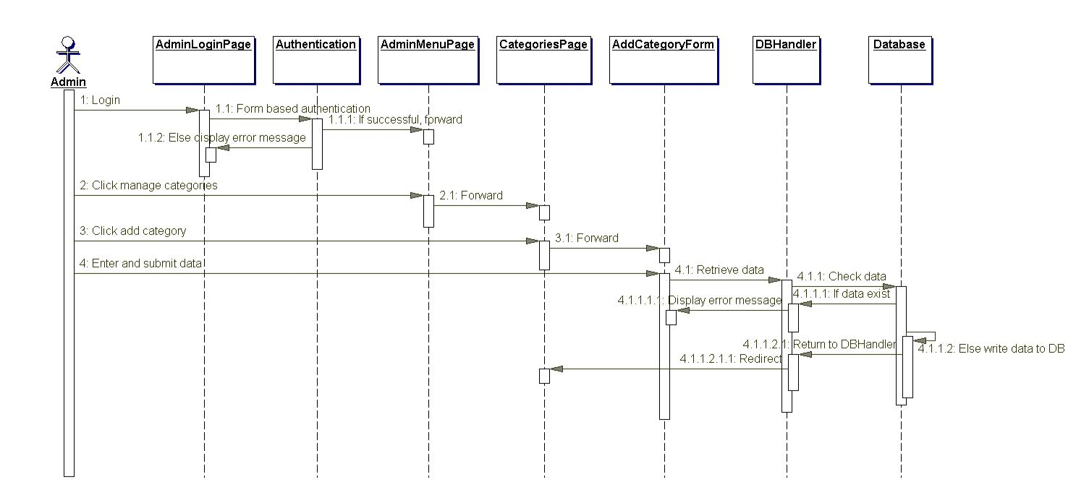

Figure 25. Add category sequence diagram.
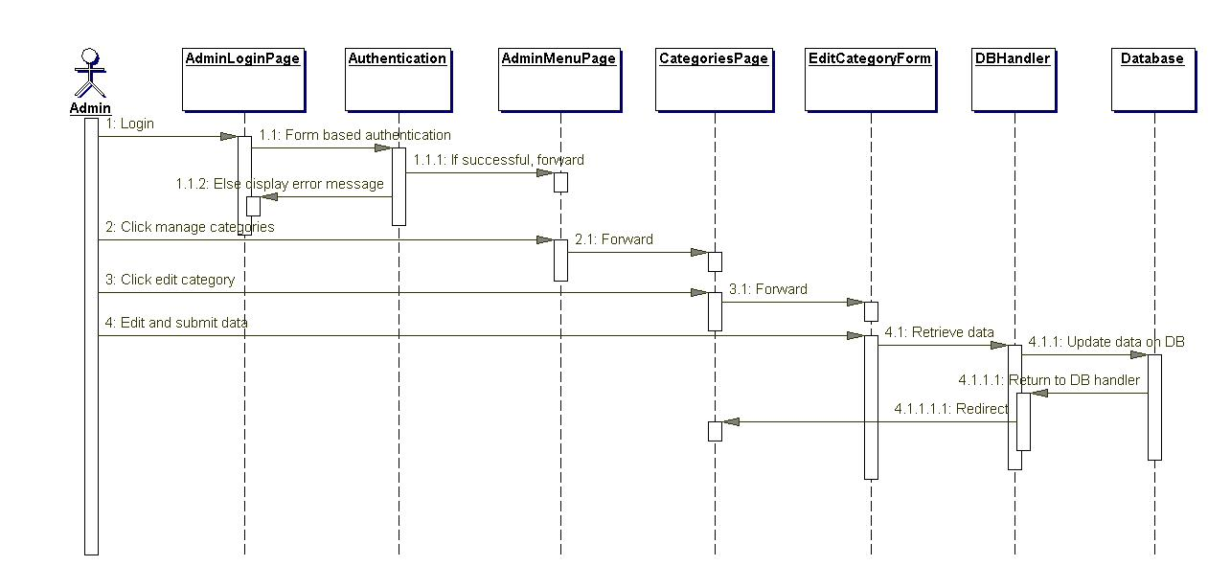

Figure 26. Edit category sequence diagram.

67
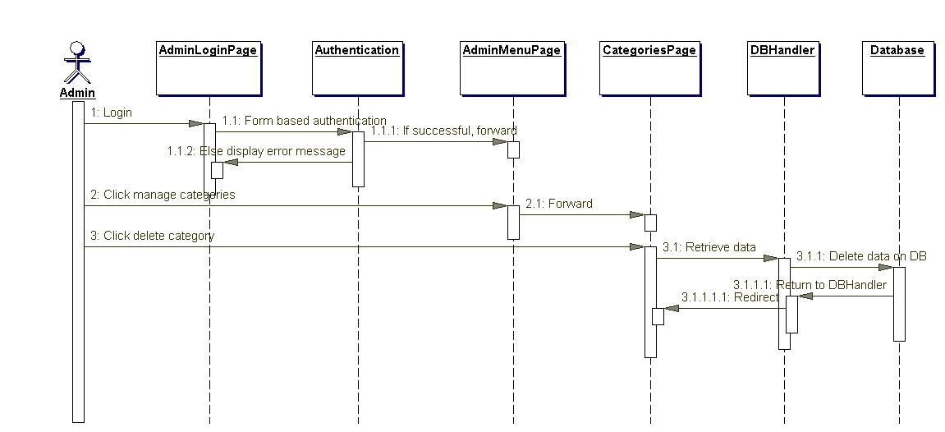

Figure 27. Delete category sequence diagram.
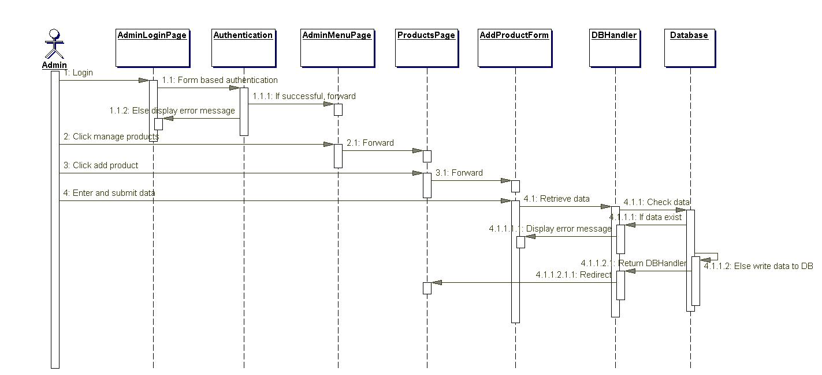

Figure 28. Add product sequence diagram.
68
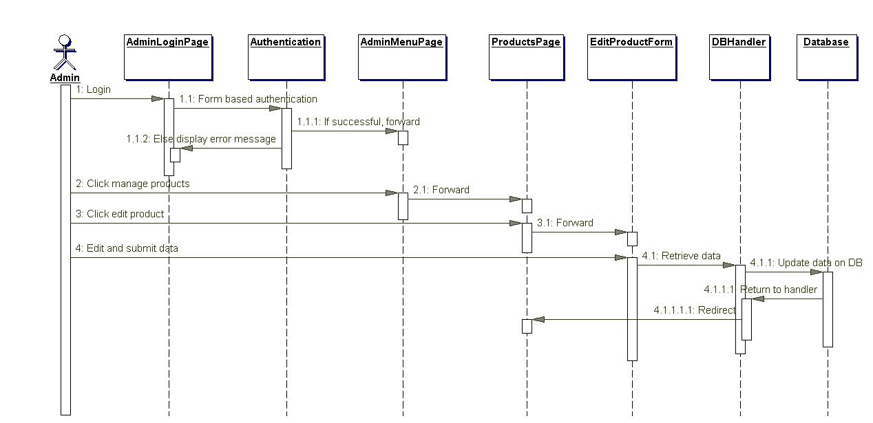

Figure 29. Edit product sequence diagram.
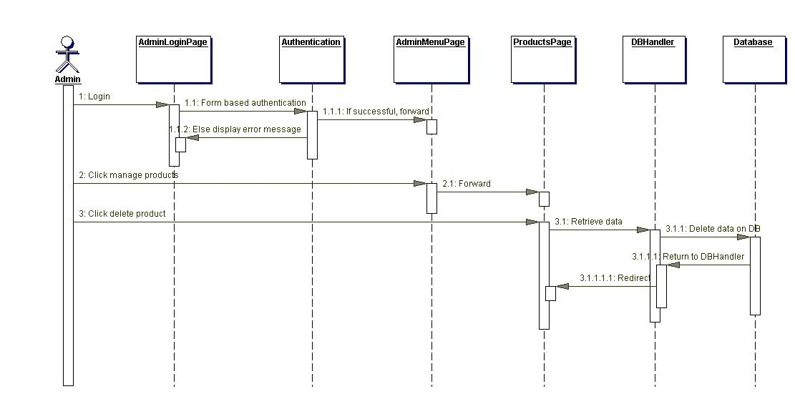

Figure 30. Delete product sequence diagram.
69
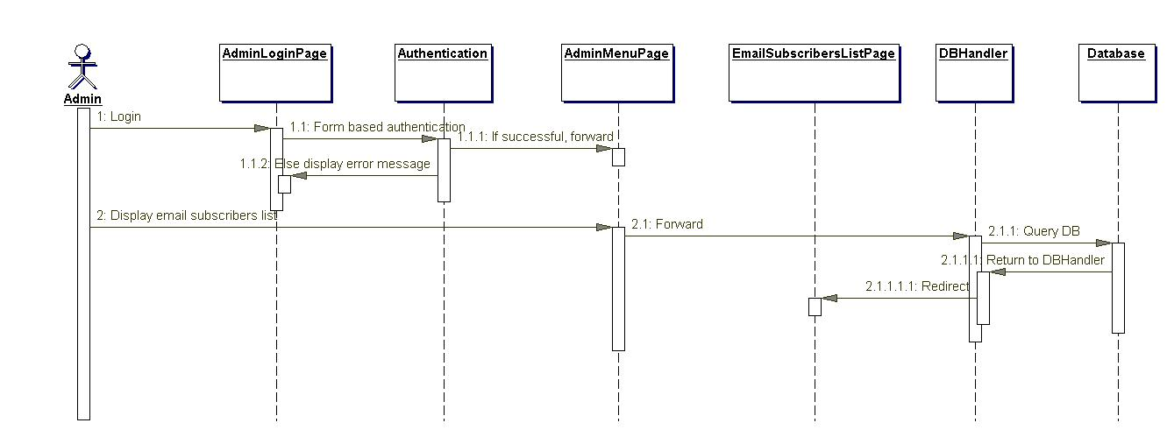

Figure 31. Display email subscribers' list diagram.
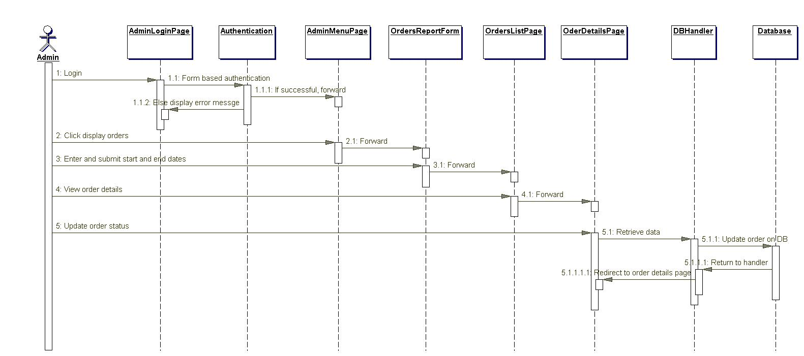

Figure 32. Display orders list sequence diagram.

70
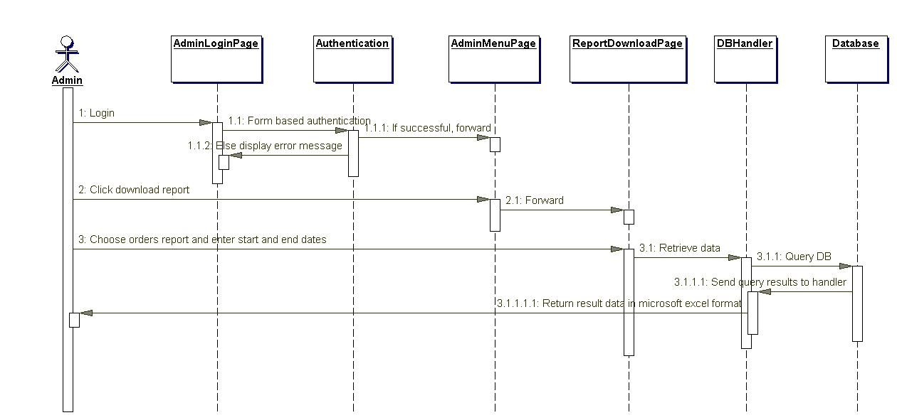

Figure 33. Download orders report sequence diagram.
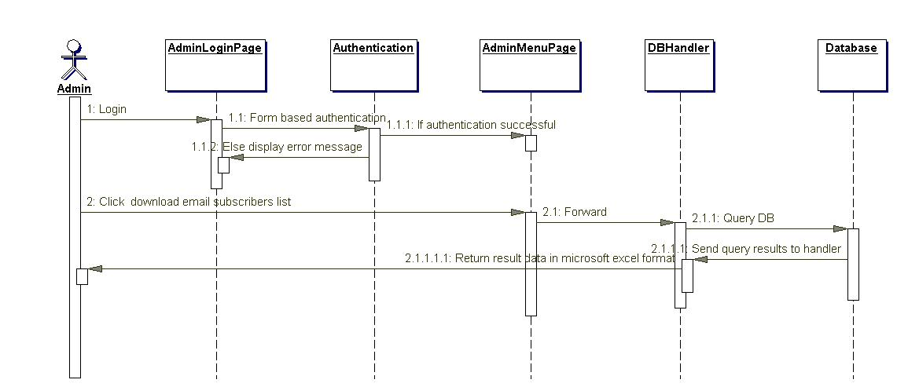

Figure 34. Download email subscribers list sequence diagram.

CHAPTER 4

FUTURE SCOPE

Future scope of application:
Thus application can be easily implemented under various situations. We can add new features as and when we require. Reusability is possible as and when require in this application.

Software Scope:
    - Extensibility: This software is extensible in ways that its original developers may not expect the principles like hide data structure, avoid traversing multiple links or methods, avoid case statements on object type and distinguish public and private operations enhances extensibility.
    - Reusability: Reusability is possible as and when require in this application.
    - Understandability: A method is understandable if someone other than the creator of the method can understand the code.
    - Cost-effectiveness:- Its cost is under the budget and make within given time period. It is desirable for a system with minimum cost subject to the condition that it must satisfy the entire requirement.

